

FIND MY INFLUENCER

*Influencer Profiles*

2025

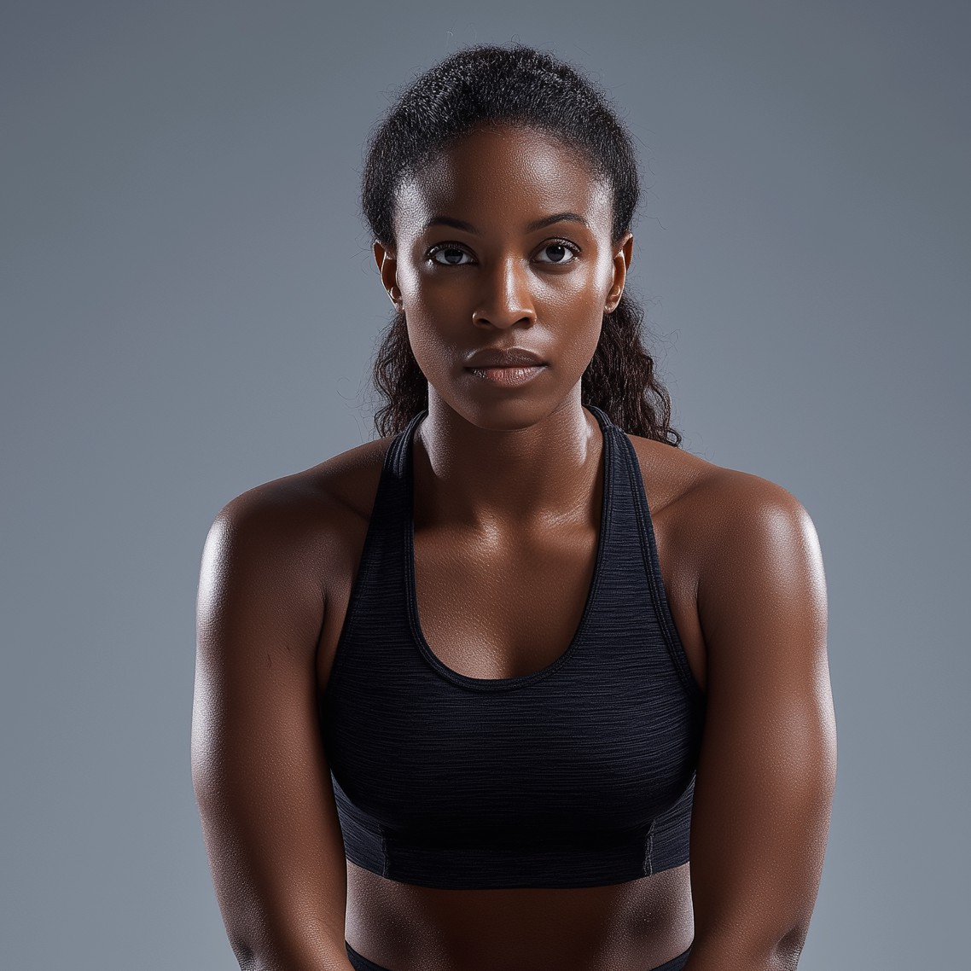

Amira (@amira.moves)

1. Influencer Handle
   * Brand/Alias: amira.moves
   * Main Handles:
     + Instagram: @amira.moves
     + TikTok: @amira.moves
     + YouTube: Amira Moves
2. Platform(s) & Follower Counts
   * Instagram: 1,000,500 followers
   * TikTok: 950,000 followers
   * YouTube: 730,000 subscribers
3. Content Type & Niche
   * Primary Content: Fitness, wellness, lifestyle
   * Sub-genres/Series:
     + “Fit Looks” (sustainable outfit hauls)
     + “Run With Me” (morning runs in London parks)
     + “Mindful Reset” (meditation and rest day routines)
     + Occasional astrology-inspired motivation posts
4. Posting Frequency & Activity
   * Typical Posts:
     + Instagram: 4-5 posts/week + daily stories
     + TikTok: 3 videos/week
     + YouTube: 1 video/week (usually “day in the life” or workout vlog)
   * Activity: Consistent, with occasional week-long breaks for “digital detox” or travel
5. Audience Demographics
   * Age Distribution:

o 18–24: 52%

o 25–34: 37%

o 35+: 11%

* + Gender Split: 72% women, 25% men, 3% non-binary/other
  + Top Locations: London, Manchester, Birmingham, Toronto
  + Other Insights:
    - Audience is highly interested in sustainability, eco-brands, running, and wellness
    - Above-average engagement from university students and young professionals

1. Engagement Metrics
   * Instagram:
     + Avg. likes/post: 37,000
     + Avg. comments/post: 1,400
     + Engagement rate: 3.8%
     + Reach/impressions: 260,000 avg. per post
   * TikTok:
     + Avg. views/video: 110,000
     + Avg. comments/video: 750
     + Engagement rate: 2.7%
   * YouTube:
     + Avg. views/video: 54,000
     + Avg. comments/video: 350
     + Engagement rate: 1.6%
2. Brand Partnerships & Sponsored Content
   * Brands Worked With:
     + GreenStride, Nike Move, Sable Water, ChillAloe, Adidas Run Club, ReGreener
   * Types of Sponsored Content:
     + Product reviews, unboxings, IG takeovers, sponsored runs, eco-brand roundups, paid story Q&As
3. Brand Persona & Image
   * Traits: Upbeat, approachable, ethical, motivating, spiritual (astrology, crystals)
   * Voice/Style: Warm, chatty, positive; on camera, mixes encouragement with dry humor.
4. Potential Audience Overlaps
   * Overlap With:
     + Maya (wellness, mindfulness), Cassie (body positivity, running), Layla (London- based wellness)
5. Potential Controversies
   * Known for “life update” stories that sometimes spiral into astrology or pop culture tangents; some brand partners see this as off-message
   * Addresses feedback openly, known for apologizing or clarifying if a post gets misunderstood
6. Pricing & Collaboration Terms
   * Instagram Post: £4,200
   * Instagram Story (3 slides): £1,100
   * TikTok Video: £2,000
   * YouTube Video Integration: £3,500
   * Multi Cross-platform (one post per platform): £9,500
   * Discounts: 20% off for 2+ platforms; 15% off/month for campaigns >3 months
   * Negotiation: Open, but prefers eco-conscious brands and campaigns with charity tie-ins
7. Strengths & Unique Selling Points
   * Exceptional engagement for her tier
   * Deep authenticity in eco/wellness space (walks the talk)
   * Connects strongly with women and BIPOC runners
   * Gorgeous visuals (her IG is “moodboard” level)

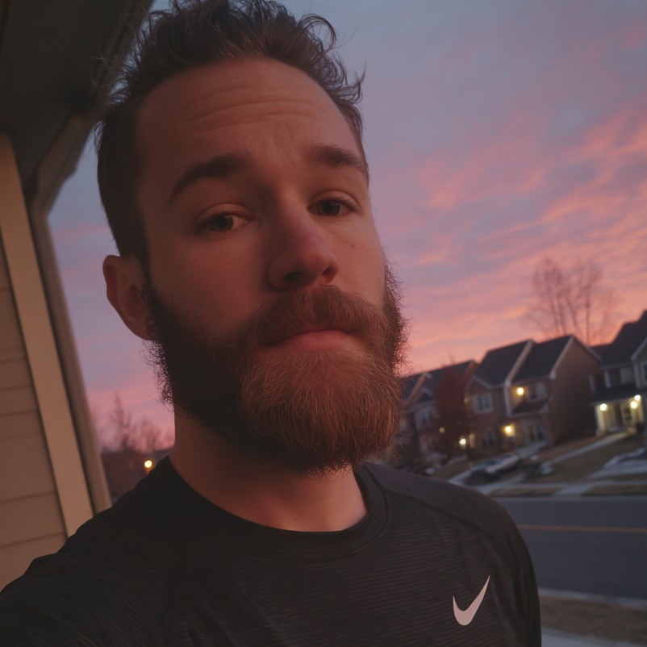

Luca (@lucab_run)

1. Influencer Handle
   * Brand/Alias: lucab_run
   * Main Handles:
     + Instagram: @lucab_run
     + TikTok: @lucab_run
     + YouTube: Luca
2. Platform(s) & Follower Counts
   * Instagram: 720,000 followers
   * YouTube: 820,000 subscribers
   * TikTok: 915,000 followers
3. Content Type & Niche
   * Primary Content: Running, lifestyle, vlogs, fitness tips
   * Sub-genres/Series:
     + “Run & Rant” (comedic running commentaries, often filmed during actual runs)
     + “Race Day Vlogs” (in-depth, start-to-finish coverage of major and minor UK races)
     + “Challenge Accepted” (monthly endurance or pace challenges, often with audience dares)
     + “Gear Check” (running tech, sneakers, and performance wear reviews)
4. Posting Frequency & Activity
   * Typical Posts:
     + Instagram: 3–4 posts/week + regular stories
     + TikTok: 2–3 videos/week
     + YouTube: 1–2 videos/week (vlogs, reviews, challenges)
   * Activity: Generally consistent but takes spontaneous multi-day “offline” breaks for mental health; fans are used to it
5. Audience Demographics
   * Age Distribution:

o 18–24: 42%

o 25–34: 45%

o 35+: 13%

* + Gender Split: 52% men, 47% women, 1% non-binary/other
  + Top Locations: London, Edinburgh, Liverpool, Bristol, Dublin
  + Other Insights:
    - Large proportion are aspiring runners and student-athletes
    - Fans engage heavily with challenge and race content, plus gear recommendations

1. Engagement Metrics
   * Instagram:
     + Avg. likes/post: 28,000
     + Avg. comments/post: 900
     + Engagement rate: 3.2%
     + Reach/impressions: 180,000 avg. per post
   * TikTok:
     + Avg. views/video: 98,000
     + Avg. comments/video: 480
     + Engagement rate: 2.5%
   * YouTube:
     + Avg. views/video: 66,000
     + Avg. comments/video: 530
     + Engagement rate: 2.1%
2. Brand Partnerships & Sponsored Content
   * Brands Worked With:
     + PaceLab, GatorLite UK, Adidas Run Club, JogLog, FlexiFuel, SunStreak Sunglasses
   * Types of Sponsored Content:
     + Challenge integrations, gear reviews, sponsored race entries, IG stories with product shoutouts, branded giveaway runs
3. Brand Persona & Image
   * Traits: Dry humor, practical, relatable, slightly chaotic, ultra-competitive, a little irreverent
   * Voice/Style: Witty and self-deprecating; mixes pep talks with running memes and pop culture riffs; delivers honest, sometimes blunt, reviews
4. Potential Audience Overlaps
   * Overlap With:
     + Dev (tech/gear reviews), Miles (sneaker and race day hype), Cassie (relatable running/lifestyle)
5. Potential Controversies
   * Mild: Known for “disappearing” periodically to recharge, which can throw off strict campaign timelines
   * Reputation: Addresses absences honestly, fans appreciate transparency; some brands

plan for delayed deliverables

1. Pricing & Collaboration Terms
   * Instagram Post: £3,600
   * Instagram Story (3 slides): £950
   * TikTok Video: £1,800
   * YouTube Video Integration: £3,100
   * Multi Cross-platform (one post per platform): £8,000
   * Discounts: 20% off for multi-platform, 10% off per additional month
   * Negotiation: Generally open, especially for running and tech brands; prefers fewer, longer-term partnerships
2. Strengths & Unique Selling Points
   * Exceptionally engaging running vlogs and humor
   * Highly trusted on gear reviews and training advice
   * Community challenges and races create loyal, repeat viewers
   * Encourages positive running culture, not just competition
   * ​

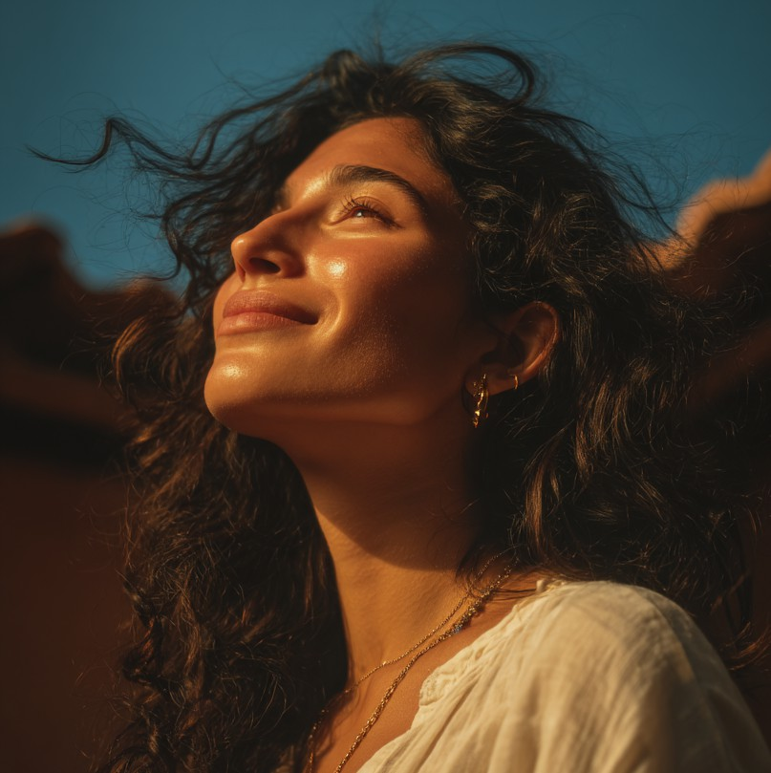

Maya (@mayathesun)

1. Influencer Handle
   * Brand/Alias: mayathesun
   * Main Handles:
     + TikTok: @mayathesun
     + Instagram: @mayathesun
     + YouTube: Maya the Sun
2. Platform(s) & Follower Counts
   * TikTok: 1,000,000 followers
   * Instagram: 980,000 followers
   * YouTube: 760,000 subscribers
3. Content Type & Niche
   * Primary Content: Mindful fitness, yoga, running, sustainable living
   * Sub-genres/Series:
     + “Mindful Movement” (blend of yoga and functional workouts)
     + “Eco Living 101” (sustainable swaps and wellness routines)
     + “Mental Health Reset” (guided meditations, journaling tips, self-care vlogs)
     + “Run with Maya” (gentle running sessions and group runs)
4. Posting Frequency & Activity
   * Typical Posts:
     + TikTok: 4 videos/week
     + Instagram: 4 posts/week + stories daily
     + YouTube: 1 longform vlog or class/week
   * Activity: Highly consistent, with a scheduled “mental health break” every other month (explained to audience)
5. Audience Demographics
   * Age Distribution:

o 18–24: 58%

o 25–34: 32%

o 35+: 10%

* + Gender Split: 81% women, 16% men, 3% non-binary/other
  + Top Locations: London, Lisbon, Mumbai, Manchester, Toronto, Birmingham
  + Other Insights:
    - Follows her for gentle motivation, sustainability, yoga, and “soothing” video style
    - Bilingual audience (English and Portuguese), small but vocal Indian following
    - Attracts students, young professionals, and expats

1. Engagement Metrics
   * TikTok:
     + Avg. views/video: 140,000
     + Avg. comments/video: 980
     + Engagement rate: 3.1%
   * Instagram:
     + Avg. likes/post: 34,000
     + Avg. comments/post: 1,200
     + Engagement rate: 3.4%
     + Stories: 87,000 avg. views
   * YouTube:
     + Avg. views/video: 46,000
     + Avg. comments/video: 410
     + Engagement rate: 1.8%
2. Brand Partnerships & Sponsored Content
   * Brands Worked With:
     + Lush Organics, BBC Earth, FlowMat, CalmSpace, GreenStride, Sable Water, Kora Activewear
   * Types of Sponsored Content:
     + Mindfulness challenges, eco-product roundups, IGTV yoga classes, “day in my life” sponsored vlogs, branded meditation guides
3. Brand Persona & Image
   * Traits: Soothing, authentic, wellness-focused, gentle authority, inclusive
   * Voice/Style: Calm, empathetic, softly spoken; her videos feature soft music, voiceovers, and serene editing
4. Potential Audience Overlaps
   * Overlap With:
     + Amira (eco-living & running), Priya (mindfulness and vegan content), Layla (wellness in London)
5. Potential Controversies
   * Mild: High portion of audience is non-UK (about 35%), so reach for UK-centric brands can be diluted
   * Reputation: Transparent about audience split; sometimes creates “local only” or “UK- only” campaigns to boost relevance
6. Pricing & Collaboration Terms
   * TikTok Video: £2,300
   * Instagram Post: £3,900
   * Instagram Stories (3 slides): £950
   * YouTube Vlog (sponsored): £3,200
   * Cross-Platform Campaign: £9,800
   * Discounts: 15% for 2+ platforms, 10% off/month for multi-month deals
   * Negotiation: Very open to “value-driven” brands and long-term partnerships, especially in eco-wellness or wellness tech
7. Strengths & Unique Selling Points
   * Bilingual, multicultural, and internationally appealing
   * High authenticity and gentle authority in the wellness space
   * Excellent at brand storytelling without feeling forced
   * Videos have “calming” effect; audience trusts her for self-care guidance

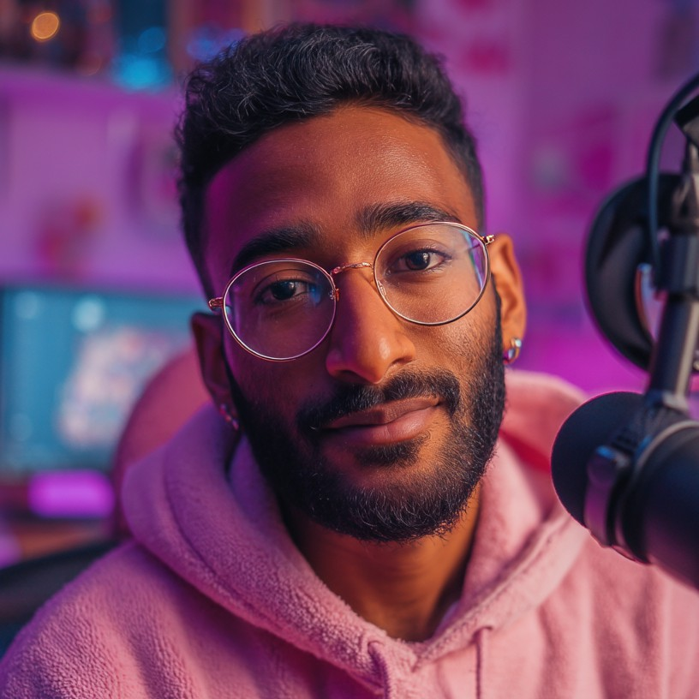

Dev (@devreviews)

1. Influencer Handle
   * Full Name: Dev
   * Brand/Alias: devreviews
   * Main Handles:
     + YouTube: Dev Reviews
     + Instagram: @devreviews
     + Twitter/X: @devreviews
2. Platform(s) & Follower Counts
   * YouTube: 980,000 subscribers
   * Instagram: 870,000 followers
   * Twitter/X: 720,000 followers
3. Content Type & Niche
   * Primary Content: Fitness technology, gear reviews, myth-busting, athletic apparel
   * Sub-genres/Series:
     + “Deep Dive Reviews” (in-depth breakdowns of running shoes, smartwatches, wearables)
     + “Mythbusting Mondays” (debunking health/fitness trends with research and demos)
     + “Performance vs. Hype” (side-by-side product stress tests)
     + “Unbox + Field Test” (real-world product demos, not just specs)
4. Posting Frequency & Activity
   * Typical Posts:
     + YouTube: 1–2 long-form videos/week (15–25 mins, highly produced)
     + Instagram: 2–3 posts/week (mostly gear closeups and short reels), stories nearly daily
     + Twitter/X: 4–5 tweets per week, mainly hot takes, Q&As, and gear news
   * Activity: Highly reliable; posts on a schedule and rarely misses uploads
5. Audience Demographics
   * Age Distribution:

o 18–24: 39%

o 25–34: 50%

o 35+: 11%

* + Gender Split: 68% men, 29% women, 3% non-binary/other
  + Top Locations: London, Birmingham, Manchester, Delhi, Toronto
  + Other Insights:
    - Large segment are techie runners, gear nerds, and performance hobbyists
    - Strong following among international students and UK urbanites
    - Audience likes data-driven, “no-BS” breakdowns

1. Engagement Metrics
   * YouTube:
     + Avg. views/video: 85,000
     + Avg. comments/video: 1,200
     + Engagement rate: 2.9%
   * Instagram:
     + Avg. likes/post: 21,000
     + Avg. comments/post: 650
     + Engagement rate: 2.4%
   * Twitter/X:
     + Avg. likes/tweet: 2,200
     + Avg. replies/tweet: 310
     + Engagement rate: 1.8%
2. Brand Partnerships & Sponsored Content
   * Brands Worked With:
     + RunTech, Adidas UK, VoltWear, Garmin, Sable Water, ReGreener, MindSprint
   * Types of Sponsored Content:
     + Sponsored gear reviews (always disclosed), campaign integrations, giveaway collaborations, “test-to-win” challenges
3. Brand Persona & Image
   * Traits: Analytical, transparent, highly knowledgeable, direct, pragmatic
   * Voice/Style: Calm, slightly dry humor, focused on objectivity; video style is clean, minimal, data-heavy with infographics and field shots
4. Potential Audience Overlaps
   * Overlap With:
     + Luca (gear, running tech), Priya (science-driven wellness), Zhang (sustainable gear, data-forward content)
5. Potential Controversies
   * Mild: Some reviews are so technical that casual or new runners may feel excluded
   * Reputation: Always discloses sponsorships, never overpromises; respected as a “straight shooter” even by competitors
6. Pricing & Collaboration Terms
   * YouTube Integration: £4,300
   * Instagram Post: £2,800
   * Instagram Reel: £1,400
   * Twitter/X Campaign: £1,100
   * Full Campaign (multi-platform): £9,800
   * Discounts: 20% for multi-platform bundles, 10%/month off for >2 months
   * Negotiation: Open, but only takes brands whose claims he can vet and stand behind
7. Strengths & Unique Selling Points
   * Deepest technical authority in running/fitness tech space
   * Audience trusts his objectivity—rarely does “hype”
   * High-quality production, excellent at making data accessible
   * Often cited by other influencers and even running blogs



Sierra (@sierra.leung)

1. Influencer Handle
   * Brand/Alias: sierra.leung
   * Main Handles:
     + Instagram: @sierra.leung
     + TikTok: @sierra.leung
     + YouTube: Sierra Leung
     + ​
2. Platform(s) & Follower Counts
   * Instagram: 910,000 followers
   * TikTok: 870,000 followers
   * YouTube: 760,000 subscribers
3. Content Type & Niche
   * Primary Content: Urban fitness, parkour, running, street style
   * Sub-genres/Series:
     + “No Excuses Challenge” (urban obstacle courses, viewer dares)
     + “Run the City” (cinematic parkour/running montages in different UK locations)
     + “Streetwear Gear Tests” (stylish, functional sports fashion)
     + “Epic Fails & Wins” (funny behind-the-scenes and stunts gone wrong)
4. Posting Frequency & Activity
   * Typical Posts:
     + Instagram: 4–5 posts/week + daily stories
     + TikTok: 3–4 videos/week
     + YouTube: 1–2 videos/week (parkour vlogs, challenge edits)
   * Activity: Extremely active and consistent; rarely misses a week
5. Audience Demographics
   * Age Distribution:

o 18–24: 54%

o 25–34: 38%

o 35+: 8%

* + Gender Split: 56% men, 41% women, 3% non-binary/other
  + Top Locations: London, Birmingham, Glasgow, Hong Kong, Liverpool
  + Other Insights:
    - Urban and suburban youth, sneakerheads, streetwear fans, and amateur athletes
    - Attracts both UK and Asian diaspora viewers, high engagement in city lifestyle subcultures

1. Engagement Metrics
   * Instagram:
     + Avg. likes/post: 23,000
     + Avg. comments/post: 1,150
     + Engagement rate: 2.9%
     + Reach/impressions: 140,000 avg. per post
   * TikTok:
     + Avg. views/video: 122,000
     + Avg. comments/video: 920
     + Engagement rate: 2.5%
   * YouTube:
     + Avg. views/video: 41,000
     + Avg. comments/video: 340
     + Engagement rate: 1.7%
2. Brand Partnerships & Sponsored Content
   * Brands Worked With:
     + PWR Moves, SupremeFit, Boost+ Bars, Adidas UK, GlowStep Sneakers, Gearup Streetwear
   * Types of Sponsored Content:
     + Streetwear haul videos, “challenge” integrations, branded city run series, product placements in viral TikToks, and pop-up events
3. Brand Persona & Image
   * Traits: Energetic, daring, creative, “urban cool,” unapologetic
   * Voice/Style: Fast-paced, high-impact visuals, direct address, bold editing; known for stunts and confident on-camera presence
4. Potential Audience Overlaps
   * Overlap With:
     + Miles (street style and sneakers), Luca (urban running), Eliot Suárez (music and city culture)
5. Potential Controversies
   * Significant: Faced controversy after third-party audit exposed a large portion of Instagram followers as bots; acknowledged issue and addressed with transparency posts and periodic follower cleanups
   * Reputation: Some brands remain cautious, but fans and many partners credit her for openly addressing the controversy and improving her account’s integrity
6. Pricing & Collaboration Terms
   * Instagram Post: £3,100
   * Instagram Story (3 slides): £850
   * TikTok Video: £2,200
   * YouTube Vlog: £2,900
   * Multi Cross-platform (one post per platform): £8,500
   * Discounts: 25% off for multi-platform, 15%/month for long-term partnerships
   * Negotiation: Open, especially to edgy and urban/activewear brands
7. Strengths & Unique Selling Points
   * High-energy, visually striking content with viral appeal
   * Unique blend of athleticism and style—“urban fitness meets streetwear”
   * Excellent at executing bold branded stunts and pop-up city events
   * Diverse, urban audience with international reach

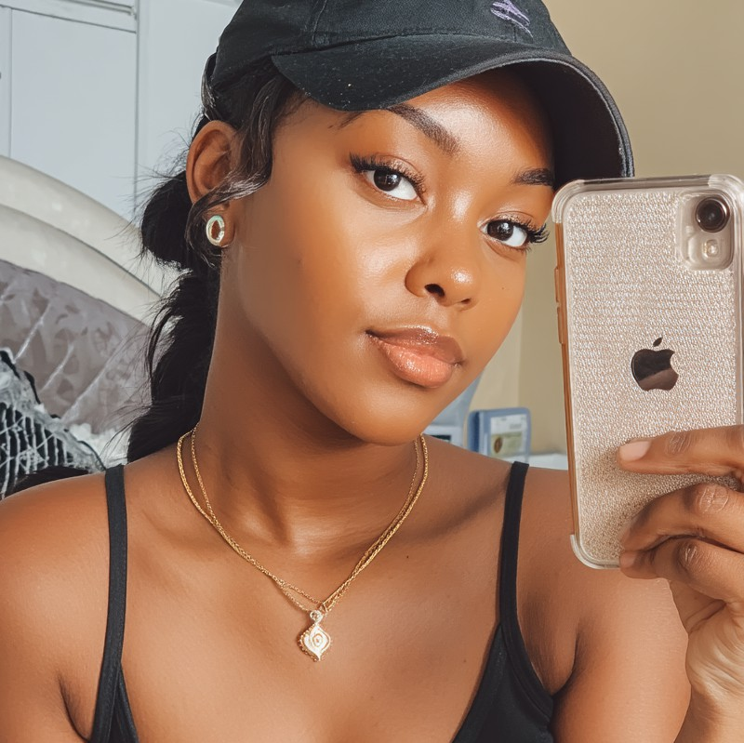

Layla (@laylafreely)

1. Influencer Handle
   * Full Name: Layla Freeman
   * Brand/Alias: laylafreely
   * Main Handles:
     + Instagram: @laylafreely
     + TikTok: @laylafreely
     + YouTube: Layla Freely
2. Platform(s) & Follower Counts
   * Instagram: 290,000 followers
   * TikTok: 380,000 followers
   * YouTube: 120,000 subscribers
3. Content Type & Niche
   * Primary Content: Lifestyle, wellness, running, skincare, meal prep
   * Sub-genres/Series:
     + “Sunday Reset” (weekly vlogs featuring cleaning, cooking, and prep routines)
     + “Skin Deep” (skincare routines and honest reviews)
     + “Running for Wellness” (gentle running routines, beginner tips)
     + “Day in the Life” (student/young professional routines, life updates)
4. Posting Frequency & Activity
   * Typical Posts:
     + Instagram: 3 posts/week + regular stories
     + TikTok: 3–4 videos/week
     + YouTube: 1 vlog/week (Sunday Reset or life update)
   * Activity: Consistent, only occasional pauses for travel or personal time
5. Audience Demographics
   * Age Distribution:

o 18–24: 61%

o 25–34: 33%

o 35+: 6%

* + Gender Split: 82% women, 16% men, 2% non-binary/other
  + Top Locations: London, Birmingham, Bristol, Manchester, Kingston (Jamaica)
  + Other Insights:
    - Follows her for relatable routines, gentle fitness, affordable wellness, and self- care tips
    - Strong appeal to students, young professionals, and Black British women
    - High engagement on posts about mental health and skincare

1. Engagement Metrics
   * Instagram:
     + Avg. likes/post: 8,700
     + Avg. comments/post: 370
     + Engagement rate: 3.1%
     + Reach/impressions: 32,000 avg. per post
   * TikTok:
     + Avg. views/video: 28,000
     + Avg. comments/video: 200
     + Engagement rate: 2.9%
   * YouTube:
     + Avg. views/video: 9,400
     + Avg. comments/video: 120
     + Engagement rate: 1.5%
2. Brand Partnerships & Sponsored Content
   * Brands Worked With:
     + Simple Skincare, Tesco Wellness, ChillAloe, ReGreener, Sable Water, Urban Athletics, VIREO (fictional pilot campaign)
   * Types of Sponsored Content:
     + Skincare and wellness product reviews, “Reset with Me” vlogs featuring sponsored gear, morning routine integrations, sustainable haul stories
3. Brand Persona & Image
   * Traits: Warm, relatable, gentle, honest, “big sister” energy
   * Voice/Style: Friendly, soft-spoken, supportive; videos feature natural lighting, relaxed edits, and candid storytelling
4. Potential Audience Overlaps
   * Overlap With:
     + Maya (wellness/lifestyle), Cassie (body positivity), Amira (sustainable fitness/lifestyle)
5. Potential Controversies
   * Mild: Audience sometimes glosses over technical product reviews, preferring daily routines and relatable struggles
   * Reputation: Always transparent about sponsorships and mental health; highly trusted for authenticity
6. Pricing & Collaboration Terms
   * Instagram Post: £1,500
   * Instagram Story (3 slides): £400
   * TikTok Video: £1,200
   * YouTube Vlog (sponsored): £1,700
   * Multi Cross-platform (one post per platform): £3,600
   * Discounts: 15% for 2+ platforms, 12%/month for 3+ month campaigns
   * Negotiation: Flexible, prioritizes wellness and sustainable brands
7. Strengths & Unique Selling Points
   * Exceptionally relatable and trusted for wellness and lifestyle
   * “Sunday Reset” series creates habitual viewers
   * Strong role model for young Black British women
   * Gentle, supportive approach stands out in a crowded space

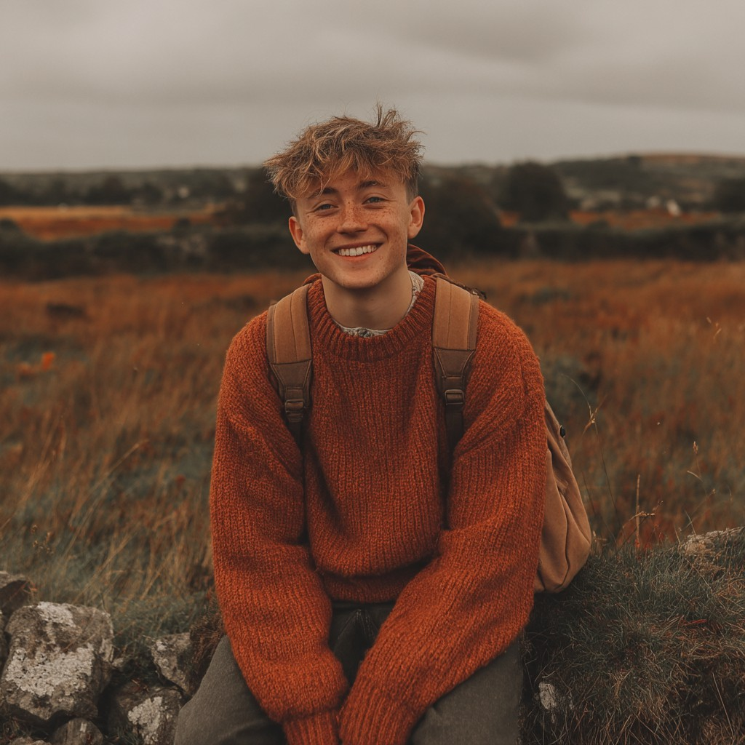

Kian Murphy (@kian.on.the.run)

1. Influencer Handle
   * Full Name: Kian Murphy
   * Brand/Alias: kian.on.the.run
   * Main Handles:
     + YouTube: Kian on the Run
     + Instagram: @kian.on.the.run
     + TikTok: @kian.on.the.run
2. Platform(s) & Follower Counts
   * YouTube: 305,000 subscribers
   * Instagram: 260,000 followers
   * TikTok: 415,000 followers
3. Content Type & Niche
   * Primary Content: Outdoor adventure, urban running, travel vlogs, eco gear reviews
   * Sub-genres/Series:
     + “Day in My Life: City Runner” (cinematic running vlogs across different UK cities)
     + “Gear on the Go” (testing niche and sustainable running accessories)
     + “Local Meetups” (organizing real-world runs and collabs)
     + “Urban Adventure Challenges” (exploring hidden city trails, race day narratives)
4. Posting Frequency & Activity
   * Typical Posts:
     + YouTube: 1–2 videos/week (vlogs, gear reviews)
     + Instagram: 2–3 posts/week + regular stories (live updates from runs and meetups)
     + TikTok: 2–4 short-form videos/week (trail highlights, quick gear shoutouts)
   * Activity: Steady, with occasional travel breaks; always notifies followers when going off- grid
5. Audience Demographics
   * Age Distribution:

o 18–24: 48%

o 25–34: 43%

o 35+: 9%

* + Gender Split: 59% men, 40% women, 1% non-binary/other
  + Top Locations: Dublin, London, Manchester, Belfast, Glasgow
  + Other Insights:
    - Strong engagement from Irish runners, urban explorers, and student athletes
    - Audience loves “hidden gems” content—urban trails, niche gear, city culture
    - Significant cross-border viewership (UK/Ireland)

1. Engagement Metrics
   * YouTube:
     + Avg. views/video: 22,000
     + Avg. comments/video: 180
     + Engagement rate: 1.9%
   * Instagram:
     + Avg. likes/post: 6,200
     + Avg. comments/post: 170
     + Engagement rate: 2.6%
   * TikTok:
     + Avg. views/video: 13,000
     + Avg. comments/video: 110
     + Engagement rate: 2.1%
2. Brand Partnerships & Sponsored Content
   * Brands Worked With:
     + FlexiFuel, TrailBound, GreenStride, Boost+ Bars, Lumo Shoes, ReGreener
   * Types of Sponsored Content:
     + Gear review integrations, “city run” event sponsorships, sustainable brand shoutouts, and Instagram Live Q&As with product demos
3. Brand Persona & Image
   * Traits: Adventurous, friendly, approachable, “local legend”
   * Voice/Style: Cinematic but down-to-earth; narrates runs with practical advice, banter, and scenic shots; easygoing with an Irish lilt
4. Potential Audience Overlaps
   * Overlap With:
     + Luca (urban running), Miles (gear reviews, street culture), Sierra (city fitness challenges)
5. Potential Controversies
   * Notable: 40% of audience is Irish rather than UK-based—potential misfit for UK-only campaigns
   * Reputation: Transparent about audience split and happy to target Irish and cross-border UK campaigns
6. Pricing & Collaboration Terms
   * YouTube Integration: £1,900
   * Instagram Post: £950
   * Instagram Story (3 slides): £320
   * TikTok Video: £750
   * Multi Cross-platform (one post per platform): £2,900
   * Discounts: 20% for cross-platform bundles, 10%/month for long-term contracts
   * Negotiation: Flexible and open to collabs with niche or student-friendly brands
7. Strengths & Unique Selling Points
   * Great crossover audience—strong in both Ireland and UK
   * Exceptional at making “city running” accessible and fun
   * Real-world meetups foster highly loyal, active local community
   * Adventure/hidden gems content gives brands an “explorer” edge

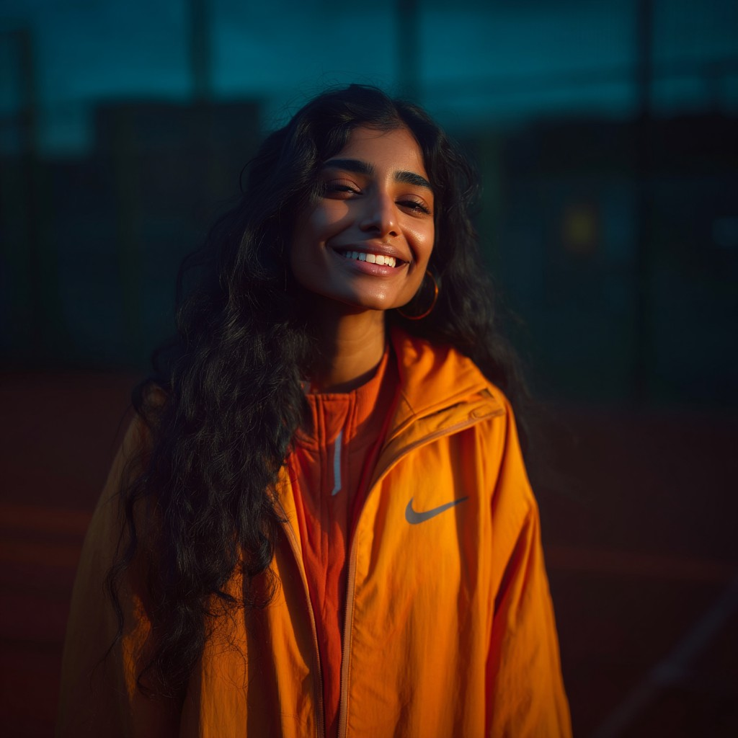

Hiba (@hibatriesagain)

1. Influencer Handle
   * Brand/Alias: hibatriesagain
   * Main Handles:
     + Instagram: @hibatriesagain
     + TikTok: @hibatriesagain
     + YouTube: Hiba Tries Again
2. Platform(s) & Follower Counts
   * Instagram: 220,000 followers
   * TikTok: 178,000 followers
   * YouTube: 146,000 subscribers
3. Content Type & Niche
   * Primary Content: Fitness, running, wellness, humor
   * Sub-genres/Series:
     + “Try With Hiba” (funny fitness challenges, first-time reviews of brands and gear)
     + “Charity Run Diaries” (vlogs from fundraising and wellness events)
     + “Swap Spotlight” (sustainable product swaps, often with giveaways)
     + “Fitness for Fun” (skits, lighthearted training videos, and group runs)
4. Posting Frequency & Activity
   * Typical Posts:
     + Instagram: 3–4 posts/week + frequent stories
     + TikTok: 3 videos/week
     + YouTube: 1–2 videos/month (challenge series, vlogs)
   * Activity: Very active, with occasional short breaks for event travel or Ramadan
5. Audience Demographics
   * Age Distribution:

o 18–24: 62%

o 25–34: 28%

o 35+: 10%

* + Gender Split: 76% women, 22% men, 2% non-binary/other
  + Top Locations: Manchester, Birmingham, London, Bradford, Lahore
  + Other Insights:
    - Audience loves humor, peer challenges, and approachable fitness
    - Highly engaged South Asian and Muslim women audience
    - Strong interest in eco swaps, peer-to-peer recommendations, and community events

1. Engagement Metrics
   * Instagram:
     + Avg. likes/post: 5,900
     + Avg. comments/post: 220
     + Engagement rate: 2.7%
     + Stories: 19,000 avg. views
   * TikTok:
     + Avg. views/video: 17,000
     + Avg. comments/video: 110
     + Engagement rate: 2.5%
   * YouTube:
     + Avg. views/video: 4,200
     + Avg. comments/video: 70
     + Engagement rate: 1.2%
2. Brand Partnerships & Sponsored Content
   * Brands Worked With:
     + MoveMore UK, VIREO, ChillAloe, Sable Water, StepUp Apparel, TidyGreen
   * Types of Sponsored Content:
     + Challenge integrations, event appearances, eco swap reviews, charity run sponsorships, TikTok challenge series
3. Brand Persona & Image
   * Traits: Energetic, humorous, inclusive, playful, “your workout BFF”
   * Voice/Style: Goofy, enthusiastic, never takes herself too seriously; relatable, high-energy edits with candid voiceovers
4. Potential Audience Overlaps
   * Overlap With:
     + Layla (wellness for women), Cassie (fitness for beginners), Priya (eco swaps and vegan lifestyle)
5. Potential Controversies
   * Mild: Posts sometimes get muted or taken down due to use of copyrighted/trending sounds in challenge videos
   * Reputation: Addresses copyright flags openly, asks audience for royalty-free music suggestions; fans appreciate her transparency
6. Pricing & Collaboration Terms
   * Instagram Post: £1,200
   * Instagram Story (3 slides): £360
   * TikTok Video: £900
   * YouTube Video: £1,500
   * Multi Cross-platform (one post per platform): £2,700
   * Discounts: 20% for misc. bundles, 12%/month for multi-month partnerships
   * Negotiation: Flexible, loves collab-based and charity-integrated projects
7. Strengths & Unique Selling Points
   * Humor and “challenge” angle drives engagement and virality
   * Excellent at building community around peer-to-peer challenges
   * Relatable, supportive, and especially trusted by South Asian and Muslim women
   * Quick to adapt to new trends and audience suggestions

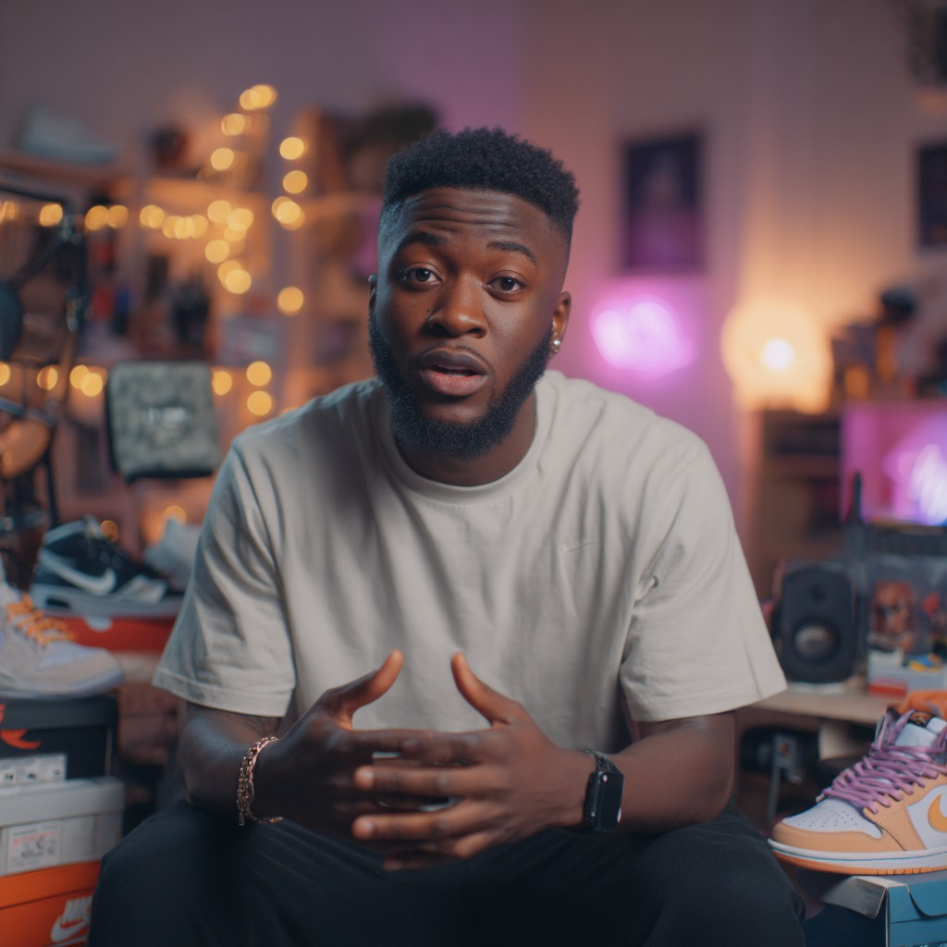

Miles (@milesdadondada)

1. Influencer Handle
   * Full Name: Miles
   * Brand/Alias: milesdadondada
   * Main Handles:
     + Instagram: @milesdadondada
     + TikTok: @milesdadondada
     + Twitter/X: @milesdadondada
2. Platform(s) & Follower Counts
   * Instagram: 450,000 followers
   * TikTok: 220,000 followers
   * Twitter/X: 130,000 followers
3. Content Type & Niche
   * Primary Content: Urban running, sneaker reviews, street style, gear drops
   * Sub-genres/Series:
     + “Sneaker Spotlight” (unboxing and reviewing new running shoes)
     + “Urban Run Tour” (exploring city neighborhoods and urban trails)
     + “Hype vs. Performance” (rating trendy gear for actual use)
     + “Debate Night” (Twitter threads debating running tech and sneaker releases)
4. Posting Frequency & Activity
   * Typical Posts:
     + Instagram: 3 posts/week + stories several times/week (unboxings, Q&As, style picks)
     + TikTok: 2 videos/week (sneaker closeups, quick gear reviews)
     + Twitter/X: 4–7 tweets/week (debates, live race commentary, meme threads)
   * Activity: Very consistent, highly responsive to sneaker drops and trending news
5. Audience Demographics
   * Age Distribution:

o 18–24: 51%

o 25–34: 41%

o 35+: 8%

* + Gender Split: 62% men, 35% women, 3% non-binary/other
  + Top Locations: London, Birmingham, Manchester, New York City
  + Other Insights:
    - Fans are sneakerheads, urban runners, street style followers, and gear enthusiasts
    - Engaged, high-energy community—loves polls and debates about gear

1. Engagement Metrics
   * Instagram:
     + Avg. likes/post: 13,800
     + Avg. comments/post: 510
     + Engagement rate: 2.9%
     + Stories: 41,000 avg. views
   * TikTok:
     + Avg. views/video: 18,000
     + Avg. comments/video: 120
     + Engagement rate: 2.6%
   * Twitter/X:
     + Avg. likes/tweet: 1,200
     + Avg. replies/tweet: 240
     + Engagement rate: 1.6%
2. Brand Partnerships & Sponsored Content
   * Brands Worked With:
     + EcoRun (VIREO), Nike, Boost+ Bars, JogLog, Foot Locker UK, Lumo Shoes
   * Types of Sponsored Content:
     + Sneaker unboxings and reviews, “hype drops” campaigns, Instagram Live Q&As, Twitter poll integrations, branded urban runs
3. Brand Persona & Image
   * Traits: Witty, trend-savvy, urban, energetic, unapologetic
   * Voice/Style: Fast-talking, meme-driven, direct; mixes genuine enthusiasm with tongue- in-cheek critiques
4. Potential Audience Overlaps
   * Overlap With:
     + Sierra (streetwear, urban fitness), Luca (running tech), Kian Murphy (city running, gear)
5. Potential Controversies
   * Mild: Gets drawn into heated sneaker and gear debates on Twitter, sometimes sparking strong opinions and brand “wars”
   * Reputation: Known for owning his takes, sometimes posts clarifications if debates get out of hand; fans appreciate his honesty
6. Pricing & Collaboration Terms
   * Instagram Post: £2,200
   * Instagram Story (3 slides): £620
   * TikTok Video: £1,300
   * Twitter/X Campaign: £800
   * Multi Cross-platform (one post per platform): £4,000
   * Discounts: 20% for cross-platform, 10%/month for multi-month
   * Negotiation: Prefers brands with “real street cred,” flexible on bundle deals
7. Strengths & Unique Selling Points
   * Expert in both “hype” and actual performance gear
   * High trust among sneaker and urban fitness fans
   * Drives energetic conversations and product virality
   * Strong reach among Black British and Ghanaian urban youth

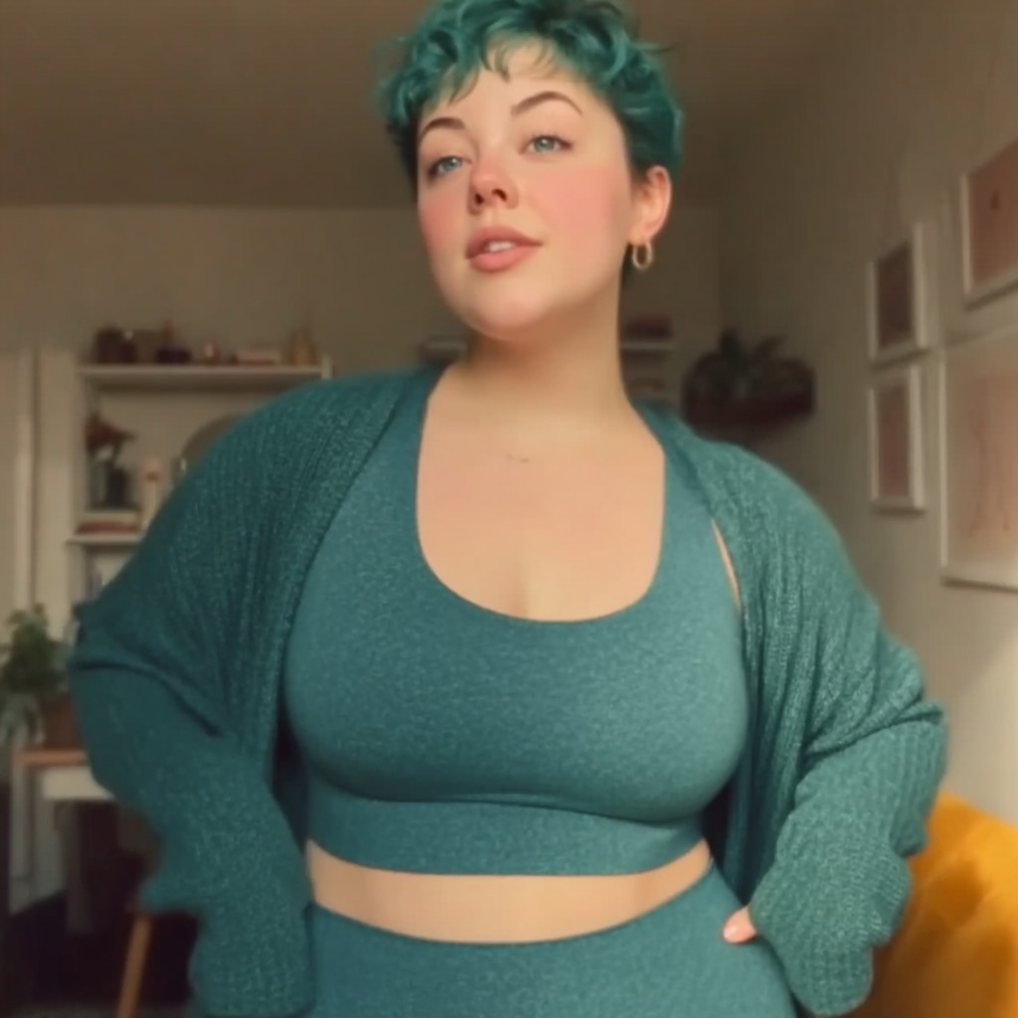

Cassie (@cassmakesachange)

1. Influencer Handle
   * Brand/Alias: cassmakesachange
   * Main Handles:
     + TikTok: @cassmakesachange02
     + Instagram: @cassmakesachange
     + YouTube: Cass Makes A Change
2. Platform(s) & Follower Counts
   * TikTok: 180,000 followers
   * Instagram: 260,000 followers
   * YouTube: 104,000 subscribers
3. Content Type & Niche
   * Primary Content: Body positivity, plus-size fitness, running for all, community self-care
   * Sub-genres/Series:
     + “Move for Joy” (celebrating non-competitive movement, fun runs)
     + “Gear for Every Body” (honest reviews of running/lifestyle products for plus-size and non-binary runners)
     + “Q&A Sundays” (answering community questions about fitness, motivation, and mental health)
     + “Workout Real Talk” (debunking fitness myths and addressing toxic fitness culture)
4. Posting Frequency & Activity
   * Typical Posts:
     + TikTok: 3 videos/week (skits, gear reviews, pep talks)
     + Instagram: 2 posts/week + stories (outfit shares, fitness memes, Q&As)
     + YouTube: 2–3 videos/month (community collabs, vlogs, tutorials)
   * Activity: Very consistent, rarely takes breaks longer than a few days
5. Audience Demographics
   * Age Distribution:

o 18–24: 49%

o 25–34: 45%

o 35+: 6%

* + Gender Split: 70% women, 20% men, 10% non-binary/other
  + Top Locations: London, Leeds, Sheffield, Manchester, Cardiff
  + Other Insights:
    - Community of plus-size runners, LGBTQ+ athletes, and body-positive advocates
    - Audience loves interactive challenges and authentic gear reviews
    - Regular engagement from non-binary and queer followers

1. Engagement Metrics
   * TikTok:
     + Avg. views/video: 12,000
     + Avg. comments/video: 100
     + Engagement rate: 2.4%
   * Instagram:
     + Avg. likes/post: 8,000
     + Avg. comments/post: 300
     + Engagement rate: 2.8%
     + Stories: 18,000 avg. views
   * YouTube:
     + Avg. views/video: 3,700
     + Avg. comments/video: 50
     + Engagement rate: 1.3%
2. Brand Partnerships & Sponsored Content
   * Brands Worked With:
     + Boldly Body, VIREO, RunHappy, GreenStride, ChillAloe
   * Types of Sponsored Content:
     + Gear reviews and hauls, body positivity Q&As, branded “move for joy” challenge videos, panel appearances for fitness diversity
3. Brand Persona & Image
   * Traits: No-nonsense, uplifting, inclusive, witty, community-driven
   * Voice/Style: Honest, slightly irreverent, uses UK pop culture references; known for deadpan delivery and dry humor
4. Potential Audience Overlaps
   * Overlap With:
     + Layla (wellness for women), Hiba (fitness for all), Amira (inclusive running), Anika Sethi (non-binary/LGBTQ+ advocacy)
5. Potential Controversies
   * Mild: Niche humor and references may confuse new or older followers; some content is very UK-specific
   * Reputation: Proactively explains jokes and engages in positive education, keeps a welcoming tone for all followers
6. Pricing & Collaboration Terms
   * TikTok Video: £850
   * Instagram Post: £1,200
   * Instagram Story (3 slides): £320
   * YouTube Video: £1,000
   * Multi Cross-platform (one post per platform): £2,500
   * Discounts: 18% for misc. bundles, 10%/month for multi-month deals
   * Negotiation: Open, especially for brands focusing on inclusivity and accessibility
7. Strengths & Unique Selling Points
   * One of the few plus-size and non-binary focused running creators
   * High trust among marginalized runners and new fitness joiners
   * Uplifting, educational content that builds genuine community
   * Honest, “real” reviews drive purchasing confidence

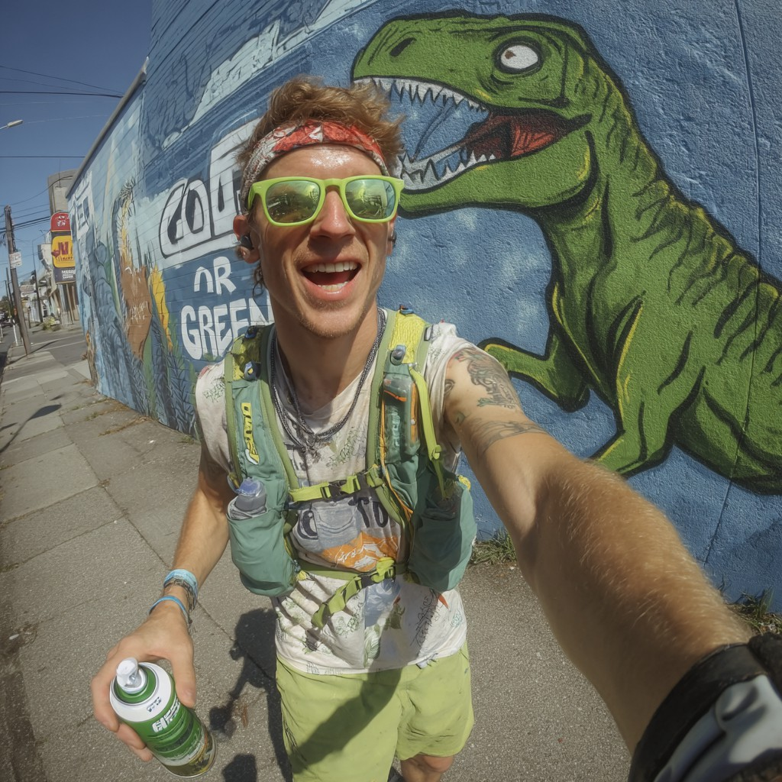

Eliot (@tagitbagitrunit)

1. Influencer Handle
   * Brand/Alias: tagitbagitrunit
   * Main Handles:
     + Instagram: @tagitbagitrunit
     + YouTube: Tag It Bag It
     + TikTok: @tagitbagitrunit
2. Platform(s) & Follower Counts
   * Instagram: 490,000 followers
   * YouTube: 310,000 subscribers
   * TikTok: 142,000 followers
3. Content Type & Niche
   * Primary Content: Running, street art, urban lifestyle, music
   * Sub-genres/Series:
     + “Graffiti Run” (urban runs with stops at famous murals and street art)
     + “Run to the Beat” (curated playlists for different running moods)
     + “Meet the Artist” (collabs/interviews with local musicians and muralists)
     + “Tips in the City” (quick advice for running safely in urban spaces)
4. Posting Frequency & Activity
   * Typical Posts:
     + Instagram: 3 posts/week + daily stories (often music and art related)
     + YouTube: 2–3 videos/month (urban vlogs, playlist collabs, art/running culture)
     + TikTok: 1–2 videos/week (urban running tips, street art moments)
   * Activity: Active, but sometimes skips weeks when working on longer creative collabs
5. Audience Demographics
   * Age Distribution:

o 18–24: 45%

o 25–34: 49%

o 35+: 6%

* + Gender Split: 57% men, 40% women, 3% non-binary/other
  + Top Locations: London, Manchester, Liverpool, Bogotá, Bristol
  + Other Insights:
    - High concentration of urban runners, music lovers, and art students
    - Strong engagement from Latin & Hispanic diaspora, and bilingual (Spanish/English) audience
    - Audience appreciates “cultural” angles as much as fitness tips

1. Engagement Metrics
   * Instagram:
     + Avg. likes/post: 16,000
     + Avg. comments/post: 540
     + Engagement rate: 2.6%
     + Stories: 51,000 avg. views
   * YouTube:
     + Avg. views/video: 13,500
     + Avg. comments/video: 180
     + Engagement rate: 1.7%
   * TikTok:
     + Avg. views/video: 7,200
     + Avg. comments/video: 60
     + Engagement rate: 2.1%
2. Brand Partnerships & Sponsored Content
   * Brands Worked With:
     + MusicBuds, GreenStride, VIREO, RunStreak, WallBeat Headphones, Spray UK
   * Types of Sponsored Content:
     + Branded playlist launches, running gear reviews, “run & art” event vlogs, music collabs, mural unveilings with fitness sponsors
3. Brand Persona & Image
   * Traits: Creative, expressive, urban, eclectic, collaborative
   * Voice/Style: Artistic, energetic, blends street culture with runner’s discipline; uses bilingual captions and upbeat soundtracks
4. Potential Audience Overlaps
   * Overlap With:
     + Miles (urban running, street style), Sierra (city/parkour), Kian Murphy (city culture), Amira (music/art crossovers)
5. Potential Controversies
   * Mild: Sometimes prioritizes unpaid creative collabs and art projects over sponsored posts, leading to irregular schedules and unpredictable deliverables
   * Reputation: Known for being upfront with partners, but some brands find him hard to schedule
6. Pricing & Collaboration Terms
   * Instagram Post: £2,700
   * Instagram Story (3 slides): £660
   * YouTube Video: £2,000
   * TikTok Video: £850
   * Multi Cross-platform (one post per platform): £4,800
   * Discounts: 20% for multi-platform, 12%/month for multi-month
   * Negotiation: Prefers creative, music/art-driven partnerships; flexible for long-term collabs
7. Strengths & Unique Selling Points
   * Unique fusion of music, art, and running content
   * Highly engaged bilingual, multicultural urban audience
   * Creative visuals, playlist curation, and in-person event hosting
   * Trusted for authenticity and cultural relevance



Priya (@priyaplacesfirst)

1. Influencer Handle
   * Brand/Alias: priyaplacesfirst
   * Main Handles:
     + Instagram: @priyaplacesfirst
     + TikTok: @priyaplacesfirst
     + YouTube: Priya Places First
2. Platform(s) & Follower Counts
   * Instagram: 400,000 followers
   * TikTok: 410,000 followers
   * YouTube: 265,000 subscribers
3. Content Type & Niche
   * Primary Content: Vegan marathon training, endurance running, food/recipes, minimalist living
   * Sub-genres/Series:
     + “Run, Eat, Repeat” (endurance training routines paired with vegan meals)
     + “Plant Power Prep” (easy vegan meal preps for runners)
     + “Marathon Minimalist” (training and lifestyle for those who want less clutter and more efficiency)
4. Posting Frequency & Activity
   * Typical Posts:
     + Instagram: 4 posts/week + frequent stories (meals, runs, Q&A)
     + TikTok: 3 videos/week (recipe demos, “run & review,” science snippets)
     + YouTube: 2 videos/month (deep-dive training or food vlogs)
   * Activity: Very consistent, with brief breaks during race travel or training peaks
5. Audience Demographics
   * Age Distribution:

o 18–24: 57%

o 25–34: 35%

o 35+: 8%

* + Gender Split: 78% women, 20% men, 2% non-binary/other
  + Top Locations: London, Leicester, Birmingham, Kochi, Bristol
  + Other Insights:
    - High engagement from vegan, vegetarian, and eco-conscious runners
    - Audience loves “snackable” science and practical nutrition tips
    - Student-heavy, many early-career professionals and international viewers

1. Engagement Metrics
   * Instagram:
     + Avg. likes/post: 11,500
     + Avg. comments/post: 460
     + Engagement rate: 2.9%
     + Stories: 32,000 avg. views
   * TikTok:
     + Avg. views/video: 16,000
     + Avg. comments/video: 150
     + Engagement rate: 2.7%
   * YouTube:
     + Avg. views/video: 6,800
     + Avg. comments/video: 120
     + Engagement rate: 1.6%
2. Brand Partnerships & Sponsored Content
   * Brands Worked With:
     + GreenStride, EcoEats, Sable Water, VIREO, VeganFuel UK, Runner’s Reset
   * Types of Sponsored Content:
     + Vegan recipe integrations, sustainable gear reviews, sponsored marathon diaries, branded science explainer posts
3. Brand Persona & Image
   * Traits: Knowledgeable, approachable, eco-driven, motivating, science-focused
   * Voice/Style: Friendly, down-to-earth, uses analogies and infographics; voiceovers are warm and occasionally cheeky
4. Potential Audience Overlaps
   * Overlap With:
     + Maya (wellness, science), Layla (practical wellness), Dev (science/data), Hiba (eco swaps)
5. Potential Controversies
   * Notable: Heavy focus on veganism sometimes alienates mainstream or flexitarian runners
   * Reputation: Handles disagreements openly, moderates debate but stands by her ethics
6. Pricing & Collaboration Terms
   * Instagram Post: £1,600
   * Instagram Story (3 slides): £480
   * TikTok Video: £1,000
   * YouTube Video: £1,600
   * Multi Cross-platform (one post per platform): £3,600
   * Discounts: 20% for misc. bundles, 10%/month for multi-month deals
   * Negotiation: Open, but prioritizes brands that are vegan, cruelty-free, and sustainability- certified
7. Strengths & Unique Selling Points
   * Makes sustainability and nutrition science accessible and fun
   * Beloved by vegan and eco-conscious runners
   * High credibility—audience trusts her research and advice
   * Combines athleticism with minimalist, relatable living

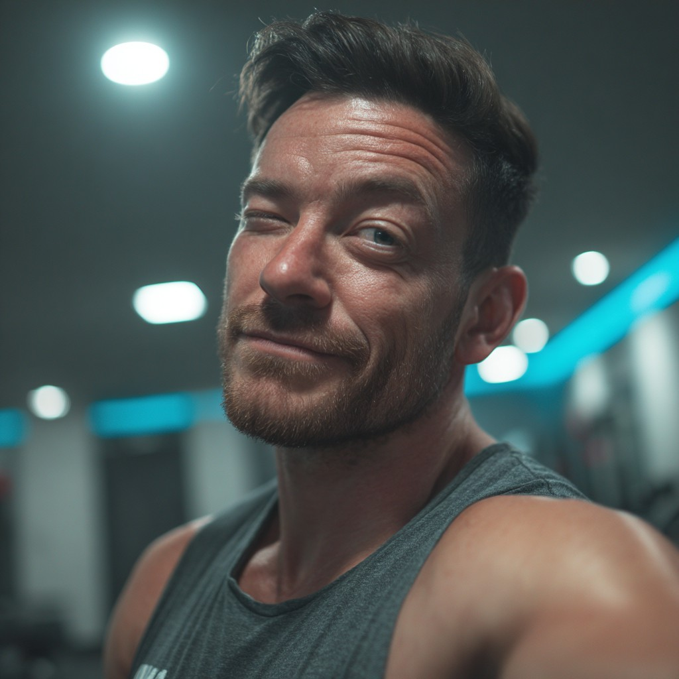

Joel (@joel.mcleod)

1. Influencer Handle
   * Full Name: Joel McLeod
   * Brand/Alias: joel.mcleod
   * Main Handles:
     + YouTube: Joel Trains
     + TikTok: @joel.mcleod
     + Instagram: @joel.mcleod
2. Platform(s) & Follower Counts
   * YouTube: 270,000 subscribers
   * TikTok: 360,000 followers
   * Instagram: 140,000 followers
3. Content Type & Niche
   * Primary Content: Fitness coaching, mythbusting, explosive workouts, recovery
   * Sub-genres/Series:
     + “Mythbusting Mondays” (debunking fitness fads, trends, and “bro science”)
     + “Explosive Workouts” (HIIT routines, circuit training, power challenges)
     + “Coach Reacts” (reviewing viral fitness clips and trends)
     + “Real Recovery” (tips, routines, and product demos)
4. Posting Frequency & Activity
   * Typical Posts:
     + YouTube: 1 video/week (mythbusting or workout feature)
     + TikTok: 3–4 videos/week (quick routines, debunks, trending audio challenges)
     + Instagram: 1–2 posts/week + regular stories (training updates, Q&A)
   * Activity: Consistent, known for timely responses to trends and controversies
5. Audience Demographics
   * Age Distribution:

o 18–24: 32%

o 25–34: 52%

o 35+: 16%

* + Gender Split: 54% men, 44% women, 2% non-binary/other
  + Top Locations: London, Glasgow, Manchester, Birmingham, Dublin
  + Other Insights:
    - Strong following among beginner-to-intermediate gym goers, new runners, and fitness mythbusters
    - Audience likes “evidence-first” approach and direct, coach-like feedback
    - Higher engagement from 25–40 age group than most VIREO influencers

1. Engagement Metrics
   * YouTube:
     + Avg. views/video: 14,800
     + Avg. comments/video: 170
     + Engagement rate: 1.6%
   * TikTok:
     + Avg. views/video: 11,000
     + Avg. comments/video: 90
     + Engagement rate: 2.0%
   * Instagram:
     + Avg. likes/post: 2,800
     + Avg. comments/post: 75
     + Engagement rate: 2.1%
     + Stories: 7,400 avg. views
2. Brand Partnerships & Sponsored Content
   * Brands Worked With:
     + FlexiFuel, JogLog, PaceLab, VIREO, ChillAloe, Adidas Run Club
   * Types of Sponsored Content:
     + Product integrations in debunking videos, “coach tries” gear reviews, challenge campaigns, Instagram Live Q&A for partner brands
3. Brand Persona & Image
   * Traits: Confident, direct, high-energy, fact-focused, “no BS” coach
   * Voice/Style: Motivational, slightly sarcastic, educational; uses evidence-based graphics, and isn’t afraid to call out misinformation
4. Potential Audience Overlaps
   * Overlap With:
     + Dev (mythbusting/data), Luca (workout challenges), Carys (real-world training)
5. Potential Controversies
   * Significant: Spread viral misinformation about “natural” injury recovery supplements, then quietly deleted videos/posts without formal apology or correction
   * Reputation: Lost some brand trust; now more explicit about source-checking and

evidence; addresses product claims carefully

1. Pricing & Collaboration Terms
   * YouTube Video: £1,600
   * TikTok Video: £1,250
   * Instagram Post: £1,200
   * Instagram Story (3 slides): £500
   * Multi Cross-platform (one post per platform): £2,700
   * Discounts: 15% for misc. bundles, 10%/month for ongoing campaigns
   * Negotiation: Open, prefers brands willing to collaborate on transparent, factual campaigns
2. Strengths & Unique Selling Points
   * Expert mythbuster; great for evidence-first campaigns
   * Trusted coach persona—direct, honest, and often motivational
   * Excellent engagement with male and older fitness audiences
   * Quick to adapt to new trends and online debates

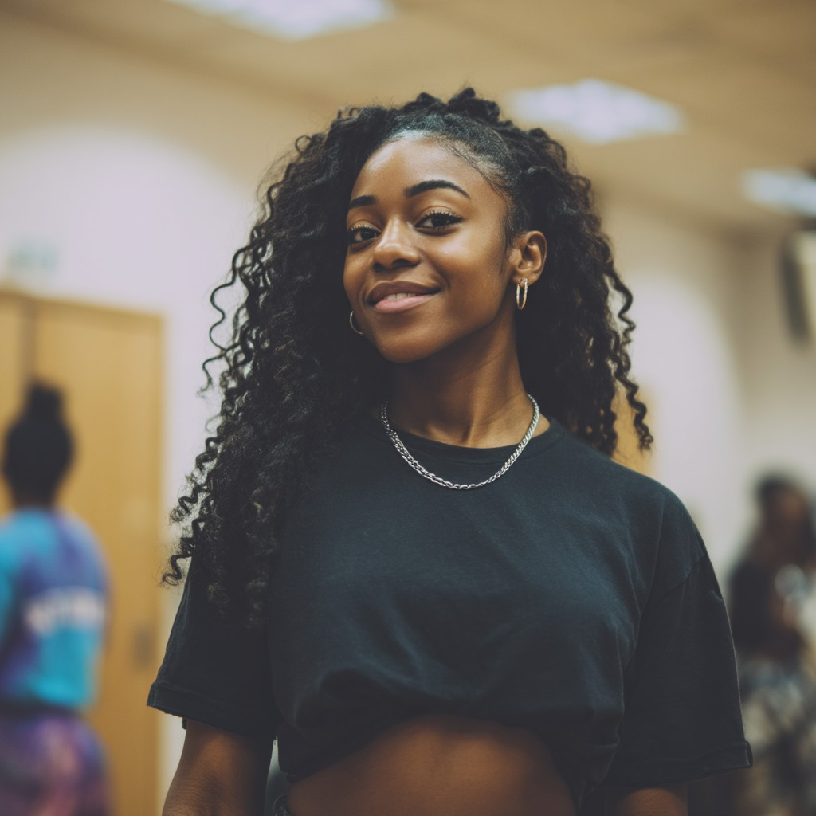

Sonia Chukwuma (@sonia.frfr)

1. Influencer Handle
   * Brand/Alias: sonia.moves
   * Main Handles:
     + Instagram: @soniafrfr
     + TikTok: @soniafrfr
     + YouTube: Sonia For Real
2. Platform(s) & Follower Counts
   * Instagram: 325,000 followers
   * TikTok: 295,000 followers
   * YouTube: 115,000 subscribers
3. Content Type & Niche
   * Primary Content: Afrobeat dance, running challenges, hybrid fitness, community motivation
   * Sub-genres/Series:
     + “Afrobeat Cardio” (dance workout routines set to trending Afrobeat tracks)
     + “Run & Move Challenge” (hybrid dance/running vlogs, sometimes as live events)
     + “Motivation Mondays” (weekly motivational pep talks, audience Q&A)
     + “IRL Moves” (recaps from meetups, charity runs, and dance sessions)
4. Posting Frequency & Activity
   * Typical Posts:
     + Instagram: 3–4 posts/week + stories (event recaps, dance clips, workout reels)
     + TikTok: 2–3 videos/week (dance trends, challenge collabs)
     + YouTube: 2–3 videos/month (choreography tutorials, challenge highlights)
   * Activity: Highly consistent, ramps up ahead of major live events
5. Audience Demographics
   * Age Distribution:

o 18–24: 60%

o 25–34: 34%

o 35+: 6%

* + Gender Split: 68% women, 29% men, 3% non-binary/other
  + Top Locations: London, Lagos, Birmingham, Manchester, Leeds
  + Other Insights:
    - Attracts dancers, runners, and young women interested in fitness with cultural flair
    - Strong engagement on IRL and community event content
    - Audience is music- and dance-driven, with notable Afro-diaspora representation

1. Engagement Metrics
   * Instagram:
     + Avg. likes/post: 10,500
     + Avg. comments/post: 380
     + Engagement rate: 2.7%
     + Stories: 23,000 avg. views
   * TikTok:
     + Avg. views/video: 15,000
     + Avg. comments/video: 90
     + Engagement rate: 2.2%
   * YouTube:
     + Avg. views/video: 3,400
     + Avg. comments/video: 40
     + Engagement rate: 1.2%
2. Brand Partnerships & Sponsored Content
   * Brands Worked With:
     + AfroVibe Fitness, DanceFuel UK, VIREO, Sable Water, GlowStep Sneakers
   * Types of Sponsored Content:
     + Dance challenge integrations, live event sponsorships, fitness product reviews, “Move With Me” dance/run collabs
3. Brand Persona & Image
   * Traits: Energetic, motivational, community-first, vibrant, culturally rooted
   * Voice/Style: Upbeat, playful, switches between dance instructor and hype coach; uses Afrobeat soundtracks and vibrant color palettes
4. Potential Audience Overlaps
   * Overlap With:
     + Hiba (challenge-driven, peer encouragement), Layla (community wellness), Sierra (active lifestyle, dance hybrid)
5. Potential Controversies
   * Mild: Sometimes prioritizes dance content over running-specific posts, diluting impact for running-only campaigns
   * Reputation: Always transparent with partners, clear about her dual focus in dance and

running

1. Pricing & Collaboration Terms
   * Instagram Post: £1,900
   * Instagram Story (3 slides): £500
   * TikTok Video: £1,200
   * YouTube Video: £1,200
   * Multi Cross-platform (one post per platform): £3,500
   * Discounts: 17% for multi-platform, 12%/month for multi-month
   * Negotiation: Loves collaborative campaigns—especially dance/run hybrid projects and IRL event sponsorships
2. Strengths & Unique Selling Points
   * Unique Afrobeat + fitness hybrid content
   * Deep community roots, both online and in-person
   * Motivational, inclusive energy—empowers women and young runners
   * Excellent event host, draws crowds for brand activations

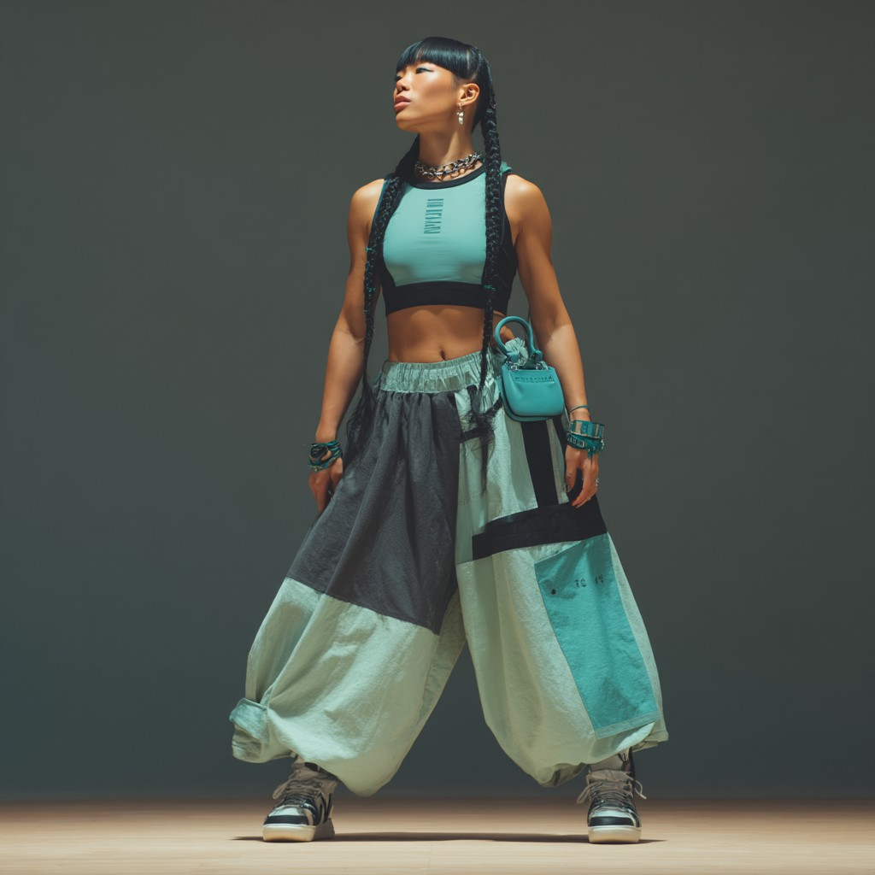

Zhang (@roryzhang)

1. Influencer Handle
   * Brand/Alias: roryzhang (previously Rory Renews)
   * Main Handles:
     + TikTok: @roryzhang
     + Instagram: @roryzhang
     + YouTube: Rory Zhang Renewed
2. Platform(s) & Follower Counts
   * TikTok: 150,000 followers
   * Instagram: 200,000 followers
   * YouTube: 90,000 subscribers
3. Content Type & Niche
   * Primary Content: Sustainable fashion for athletes, unisex gear reviews,
   * Sub-genres/Series:
     + “Fit Fashion” (sustainable/ethical activewear hauls and styling)
     + “Unisex Gear Lab” (in-depth reviews of unisex and non-gendered sports gear)
     + ing)
4. Posting Frequency & Activity
   * Typical Posts:
     + TikTok: 3 videos/week (outfit transitions, quick DIYs, reviews)
     + Instagram: 2 posts/week + stories (lookbooks, Q&As, behind-the-scenes)
     + YouTube: 2 videos/month (hauls, detailed tutorials, gear breakdowns)
   * Activity: Reliable; sticks to a content calendar and often batches posts for consistency
5. Audience Demographics
   * Age Distribution:

o 18–24: 66%

o 25–34: 29%

o 35+: 5%

* + Gender Split: 51% women, 45% men, 4% non-binary/other
  + Top Locations: London, Sheffield, Bristol, Manchester, Hong Kong
  + Other Insights:
    - Engaged student/young professional base, interested in sustainable fashion and gender-inclusive gear
    - Regular interaction from eco-advocates, university clubs, and design/fashion students

1. Engagement Metrics
   * TikTok:
     + Avg. views/video: 8,400
     + Avg. comments/video: 55
     + Engagement rate: 5.1%
   * Instagram:
     + Avg. likes/post: 6,100
     + Avg. comments/post: 180
     + Engagement rate: 4.6%
     + Stories: 20,000 avg. views
   * YouTube:
     + Avg. views/video: 2,100
     + Avg. comments/video: 35
     + Engagement rate: 4.9%
2. Brand Partnerships & Sponsored Content
   * Brands Worked With:
     + Unify Gear, GreenStride, EcoFit UK, ReGreener, Sable Water
   * Types of Sponsored Content:
     + Gear review hauls, “unboxing for good” campaigns, outfit challenges, live styling Q&As
3. Brand Persona & Image
   * Traits: Aesthetic, creative, detail-oriented, green- and design-minded
   * Voice/Style: Calm, visually polished, minimalist; uses pastel palettes, soft music, and gentle voiceovers
4. Potential Audience Overlaps
   * Overlap With:
     + Amira (eco fashion/lifestyle), Maya (eco-wellness), Priya (minimalist living), Cassie (unisex/accessible gear)
5. Potential Controversies
   * Mild: Some viewers perceive the ultra-curated aesthetic as “too perfect,” creating doubts about authenticity or relatability
   * Reputation: Occasionally posts behind-the-scenes and bloopers to “keep it real”; invites

audience for open Q&A

1. Pricing & Collaboration Terms
   * TikTok Video: £690
   * Instagram Post: £900
   * Instagram Story (3 slides): £500
   * YouTube Video: £750
   * Multi Cross-platform (one post per platform): £1,900
   * Discounts: 18% for misc. bundles, 10%/month for multi-month
   * Negotiation: Flexible, especially for eco/ethical brands and product co-designs
2. Strengths & Unique Selling Points
   * Clean, eye-catching aesthetic stands out in eco/fitness content
   * Gender-inclusive and minimalist perspective resonates with Gen Z
   * DIY and upcycling expertise builds creative engagement
   * High production value and reliable schedule

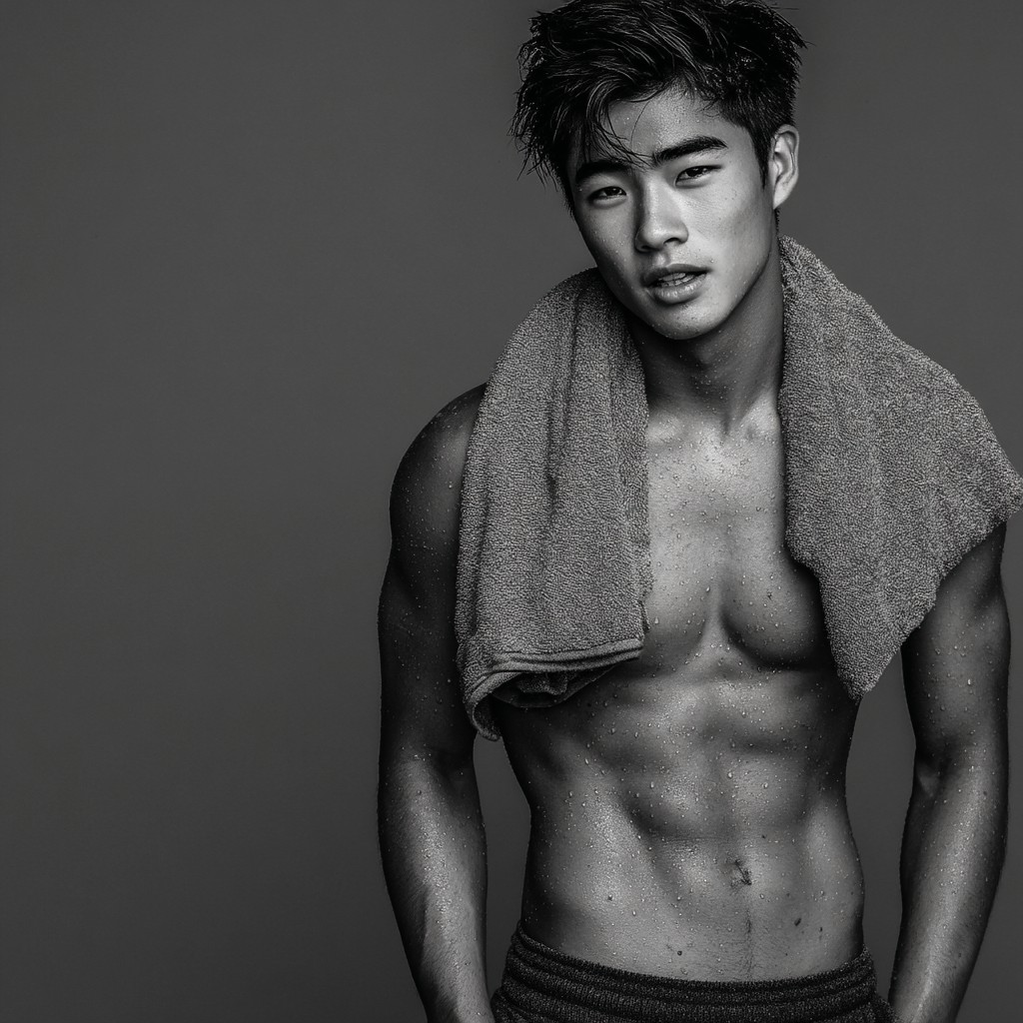

Aidan (@aidanxtreme)

1. Influencer Handle
   * Brand/Alias: aidanxtreme
   * Main Handles:
     + TikTok: @aidanxtreme
     + Instagram: @aidanxtreme
     + YouTube: Aidan Xtreme
2. Platform(s) & Follower Counts
   * TikTok: 470,000 followers
   * Instagram: 410,000 followers
   * YouTube: 150,000 subscribers
3. Content Type & Niche
   * Primary Content: Extreme workout challenges, personal fitness, viral stunts
   * Sub-genres/Series:
     + “Impossible Challenge” (attempting high-difficulty or trending fitness stunts)
     + “Livestream Lifts” (live Q&A while performing daring routines or workout feats)
     + “Behind the Flex” (training prep, recovery, and candid personality clips)
     + “Fitness Flirts” (interactive live chats, playful shoutouts, audience dares)
4. Posting Frequency & Activity
   * Typical Posts:
     + TikTok: 4–5 videos/week (challenge attempts, viral stunts, clips from lives)
     + Instagram: 3 posts/week + daily stories (highlights, behind-the-scenes, Q&As)
     + YouTube: 2–3 videos/month (full challenge vlogs, journey documentaries)
   * Activity: Highly active, especially during trending fitness challenges and event seasons
5. Audience Demographics
   * Age Distribution:

o 18–24: 54%

o 25–34: 40%

o 35+: 6%

* + Gender Split: 68% women, 29% men, 3% non-binary/other
  + Top Locations: London, Manchester, Hong Kong, Leeds, Bristol
  + Other Insights:
    - Draws energetic, young audience interested in viral fitness, spectacle, and playful banter
    - Audience appreciates boldness, confidence, and high entertainment value
    - Fans engage with polls and live interactions

1. Engagement Metrics
   * TikTok:
     + Avg. views/video: 30,000
     + Avg. comments/video: 220
     + Engagement rate: 6.6%
   * Instagram:
     + Avg. likes/post: 13,500
     + Avg. comments/post: 420
     + Engagement rate: 4.8%
     + Stories: 25,000 avg. views
   * YouTube:
     + Avg. views/video: 6,300
     + Avg. comments/video: 100
     + Engagement rate: 4.5%
2. Brand Partnerships & Sponsored Content
   * Brands Worked With:
     + XtremeWear, FlexiFuel, GlowStep, RunTech
   * Types of Sponsored Content:
     + Extreme workout gear reviews, “challenge sponsored by” integrations, IG stories with brand polls, livestream fitness Q&As
3. Brand Persona & Image
   * Traits: Bold, flirty, fearless, charismatic, competitive
   * Voice/Style: Direct, playful, high-energy, and sometimes cheeky; known for mixing encouragement with banter and visual spectacle
4. Potential Audience Overlaps
   * Overlap With:
     + Luca (challenge-driven fitness), Sierra (bold/viral stunts), Joel McLeod (workout challenges, HIIT), Sam (playful, male-focused content)
5. Potential Controversies
   * Notable: Regularly posts suggestive photos, “thirst traps”, and flirty live streams, which boost engagement but may be off-brand for more wholesome, family-friendly, or strictly professional campaigns
   * Reputation: Candid about his style; defends authenticity and audience engagement as

priorities, but some brands have paused collaborations over image concerns

1. Pricing & Collaboration Terms
   * TikTok Video: £2,500
   * Instagram Post: £2,100
   * Instagram Story (3 slides): £580
   * YouTube Video: £5,000
   * Multi Cross-platform (one post per platform): £3,900
   * Discounts: 20% for misc. bundles, 12%/month for long-term
   * Negotiation: Open, prefers dynamic brands willing to lean into the “edgy” energy
2. Strengths & Unique Selling Points
   * Viral, high-risk fitness content attracts big audiences
   * Excellent live engagement; strong, interactive fan base
   * Charismatic, memorable personality with a playful edge
   * Fearless approach brings energy to any campaign



Leah (@leahrunswild)

1. Influencer Handle
   * Brand/Alias: leahrunswild
   * Main Handles:
     + Instagram: @leahrunswild
     + TikTok: @leahrunswild
     + YouTube: Leah Runs Wild
2. Platform(s) & Follower Counts
   * Instagram: 16,000 followers
   * TikTok: 19,000 followers
   * YouTube: 7,000 subscribers
3. Content Type & Niche
   * Primary Content: Rural running, wild swimming, eco swaps, Scottish outdoors
   * Sub-genres/Series:
     + “Rural Run Diaries” (trail runs, hill climbs, rural race vlogs)
     + “Swim Wild” (vlogs and guides to wild swimming in Scottish lochs and rivers)
     + “Eco Kit Reviews” (testing and swapping sustainable gear)
     + “Scottish Scenery” (photography, location tags, mini travelogues)
4. Posting Frequency & Activity
   * Typical Posts:
     + Instagram: 2–3 posts/week (outdoor shots, eco swaps, run updates)
     + TikTok: 1–2 videos/week (wild swim highlights, gear hauls, location reveals)
     + YouTube: 1 video/2–3 weeks (long-form vlogs, wild swim journeys, gear reviews)
   * Activity: Mostly consistent, but takes planned mental health breaks; always announces time off to followers
5. Audience Demographics
   * Age Distribution:

o 18–24: 30%

o 25–34: 55%

o 35+: 15%

* + Gender Split: 66% women, 32% men, 2% non-binary/other
  + Top Locations: Edinburgh, Inverness, Aberdeen, Glasgow, Fort William
  + Other Insights:
    - Community of Scottish runners, outdoor explorers, eco-lifestyle enthusiasts
    - Strong appeal to “slow living” fans and those seeking authentic reviews of niche gear
    - Audience values transparency about mental health and sustainable living

1. Engagement Metrics
   * Instagram:
     + Avg. likes/post: 540
     + Avg. comments/post: 42
     + Engagement rate: 3.6%
     + Stories: 2,000 avg. views
   * TikTok:
     + Avg. views/video: 1,800
     + Avg. comments/video: 24
     + Engagement rate: 2.4%
   * YouTube:
     + Avg. views/video: 450
     + Avg. comments/video: 9
     + Engagement rate: 1.1%
2. Brand Partnerships & Sponsored Content
   * Brands Worked With:
     + WildKit, EcoTrail Scotland
   * Types of Sponsored Content:
     + Eco gear reviews, “run and swap” integrations, wild swim travelogues, Scottish scenery promos
3. Brand Persona & Image
   * Traits: Honest, down-to-earth, outdoorsy, reflective, eco-minded
   * Voice/Style: Calming, authentic, storytelling with strong sense of place; embraces raw nature shots and unfiltered reviews
4. Potential Audience Overlaps
   * Overlap With:
     + Maya (nature/wellness), Priya (eco swaps), Cassie (inclusive fitness), Kian Murphy (outdoor/adventure running)
5. Potential Controversies
   * Mild: Regular offline breaks to focus on mental health can lead to dips in engagement and campaign reach
   * Reputation: Widely respected for honesty and transparency; followers appreciate her boundaries and openness
6. Pricing & Collaboration Terms
   * Instagram Post: £170
   * Instagram Story (3 slides): £60
   * TikTok Video: £110
   * YouTube Video: £160
   * Multi Cross-platform (one post per platform): £390
   * Discounts: 15% for misc. bundles, 10%/month for long-term
   * Negotiation: Open and flexible, especially for eco and outdoor brands
7. Strengths & Unique Selling Points
   * Strong credibility with outdoor/adventure and “slow living” audience
   * One of the few Scottish rural/wild swim creators
   * Highly authentic, transparent about mental health and brand partnerships
   * Stunning visuals of Scottish landscapes
8. Weaknesses or Limitations
   * Smaller audience, mostly regional reach
   * Engagement dips during mental health breaks
   * Less appeal for urban, high-intensity, or trend-driven fitness campaigns
9. Sample Content
   * Instagram: “Rural Run Diary”—series of misty highland trail shots, eco gear tags, and a candid reflection on mental wellness
   * TikTok: POV wild swim montage in a glen, “Eco Kit Test” with a new VIREO bottle,

voiceover about taking time offline

* + YouTube: “Wild Swimming Loch Lomond”—vlog including sustainable gear packing, scenery, and honest review of eco-friendly running shoes

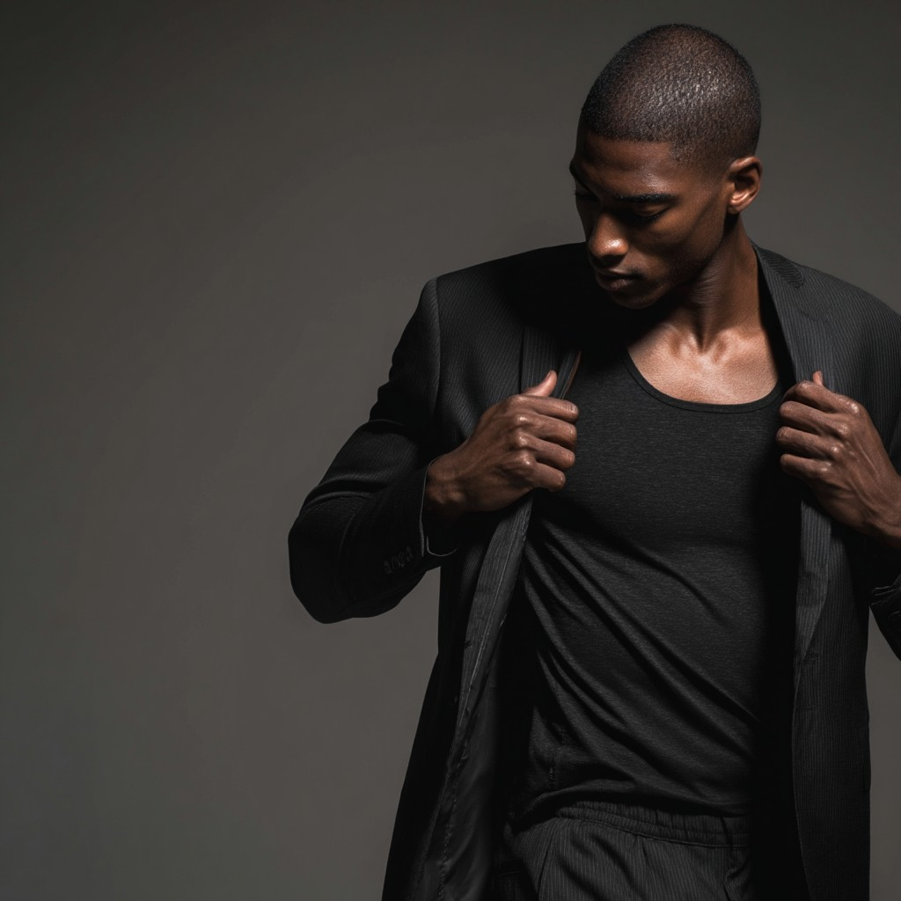

Tobi (@tobitakesoff)

1. Influencer Handle
   * Brand/Alias: tobitakesoff
   * Main Handles:
     + TikTok: @tobitakesoff
     + Instagram: @tobitakesoff
     + YouTube: Tobi Takes Off
2. Platform(s) & Follower Counts
   * TikTok: 22,000 followers
   * Instagram: 13,000 followers
   * YouTube: 4,000 subscribers
3. Content Type & Niche
   * Primary Content: City running, marathon training, work-life balance, Black-owned wellness brands, urban sustainability
   * Sub-genres/Series:
     + “Weekend Runner Diaries” (vlogs showing weekend long runs, race prep, reflections on busy workweeks)
     + “Black-Owned Wellness Spotlight” (product reviews, brand interviews, and features)
     + “Sustainable City Life” (urban eco swaps, commuting tips, and green city living)
     + “Corporate Life, Athlete Mindset” (advice on balancing training and a corporate job)
4. Posting Frequency & Activity
   * Typical Posts:
     + TikTok: 1–2 videos/week (training logs, city run highlights, quick tips)
     + Instagram: 1–2 posts/week + stories (race updates, wellness spotlights, day-in- life)
     + YouTube: 1–2 videos/month (training vlogs, brand reviews)
   * Activity: Upload schedule is inconsistent—often pauses or reduces output during peak work periods, but always updates audience when returning
5. Audience Demographics
   * Age Distribution:

o 18–24: 35%

o 25–34: 54%

o 35+: 11%

* + Gender Split: 49% men, 48% women, 3% non-binary/other
  + Top Locations: London, Birmingham, Lagos, Manchester, Bristol
  + Other Insights:
    - Audience includes professionals (esp. Black professionals), urban runners, and wellness seekers
    - Viewers appreciate relatable, “real world” content and city-specific advice
    - High engagement on posts spotlighting Black-owned brands

1. Engagement Metrics
   * TikTok:
     + Avg. views/video: 1,100
     + Avg. comments/video: 14
     + Engagement rate: 2.4%
   * Instagram:
     + Avg. likes/post: 410
     + Avg. comments/post: 12
     + Engagement rate: 3.1%
     + Stories: 900 avg. views
   * YouTube:
     + Avg. views/video: 110
     + Avg. comments/video: 2
     + Engagement rate: 0.8%
2. Brand Partnerships & Sponsored Content
   * Brands Worked With:
     + Wellness Collective, VIREO, ChillAloe, ReGreener, BlackRun UK
   * Types of Sponsored Content:
     + Sponsored gear reviews, city running campaign integrations, “weekend runner” series sponsorships, Black-owned brand highlights
3. Brand Persona & Image
   * Traits: Relatable, candid, hard-working, supportive, “everyman”
   * Voice/Style: Warm, sincere, practical; often talks directly about real-life challenges and balancing ambitions
4. Potential Audience Overlaps
   * Overlap With:
     + Layla (relatable city running), Miles (urban fitness, Black British
5. Potential Controversies
   * Mild: Inconsistent posting schedule during work peaks, sometimes missing campaign windows or real-time event coverage
   * Reputation: Followers appreciate honesty and transparency; brands sometimes have to

be flexible with campaign timing

1. Pricing & Collaboration Terms
   * TikTok Video: £160
   * Instagram Post: £90
   * Instagram Story (3 slides): £30
   * YouTube Video: £85
   * Multi Cross-platform (one post per platform): £290
   * Discounts: 15% for misc. bundles, 12%/month for long-term deals
   * Negotiation: Open, particularly for wellness, diversity, and sustainability campaigns
2. Strengths & Unique Selling Points
   * Highly relatable content for working professionals
   * Unique “weekend runner” perspective—balances career with athletic goals
   * Vocal about supporting Black-owned brands and urban sustainability
   * Honest and trustworthy, strong city runner appeal
   * ​



Bethan (@localbethanevans)

1. Influencer Handle
   * Brand/Alias: bethanrunslocal
   * Main Handles:
     + Instagram: @localbethanevans
     + TikTok: @localbethanevans
     + YouTube: Bethan Runs Local
2. Platform(s) & Follower Counts
   * Instagram: 10,000 followers
   * TikTok: 7,000 followers
   * YouTube: 2,000 subscribers
3. Content Type & Niche
   * Primary Content: Local park runs, community running events, budget eco gear reviews
   * Sub-genres/Series:
     + “Park Run Diaries” (recaps from local runs, event spotlights, participant interviews)
     + “Community Spotlights” (shoutouts to local clubs and running buddies)
     + “Run Happy Vlogs” (motivational updates, cheerful challenge series)
4. Posting Frequency & Activity
   * Typical Posts:
     + Instagram: 2 posts/week (event photos, gear reviews, community tags)
     + TikTok: 1–2 videos/week (park run highlights, budget gear unboxings)
     + YouTube: 1 video/2–3 weeks (event vlogs, eco tips)
   * Activity: Regular, sometimes spikes around big local events
5. Audience Demographics
   * Age Distribution:

o 18–24: 47%

o 25–34: 44%

o 35+: 9%

* + Gender Split: 72% women, 27% men, 1% non-binary/other
  + Top Locations: Cardiff, Swansea, Newport, Bristol, Bangor
  + Other Insights:
    - Very community-driven; followers are local runners, students, and club organizers
    - High engagement on posts featuring Welsh locations or shoutouts
    - Appeals to beginner and casual runners, especially those looking for low-cost, eco-friendly options

1. Engagement Metrics
   * Instagram:
     + Avg. likes/post: 210
     + Avg. comments/post: 16
     + Engagement rate: 2.3%
     + Stories: 420 avg. views
   * TikTok:
     + Avg. views/video: 300
     + Avg. comments/video: 5
     + Engagement rate: 1.7%
   * YouTube:
     + Avg. views/video: 70
     + Avg. comments/video: 2
     + Engagement rate: 0.9%
2. Brand Partnerships & Sponsored Content
   * Brands Worked With:
     + EcoRun Local, ChillAloe, BudgetFit
   * Types of Sponsored Content:
     + Local event sponsorships, budget gear review series, “run happy” collabs, club kit integrations
3. Brand Persona & Image
   * Traits: Cheerful, community-focused, approachable, thrifty, local ambassador
   * Voice/Style: Positive, energetic, friendly; always highlights others and community vibe
4. Potential Audience Overlaps
   * Overlap With:
     + Leah Campbell (regional/rural running), Layla (wellness on a budget), Cassie (beginner-friendly and inclusive fitness)
5. Potential Controversies
   * Mild: Heavy focus on local Welsh events and locations may limit appeal or campaign reach across the broader UK
   * Reputation: Very active in local running scene; partners must target her core (regional) audience
6. Pricing & Collaboration Terms
   * Instagram Post: £70
   * Instagram Story (3 slides): £25
   * TikTok Video: £50
   * YouTube Video: £40
   * Multi Cross-platform (one post per platform): £140
   * Discounts: 15% for misc. bundles, 10%/month for long-term
   * Negotiation: Very open, enthusiastic about any brand with eco/budget and local event tie-ins
7. Strengths & Unique Selling Points
   * Warm, approachable vibe makes beginners feel welcome
   * Unique park run ambassador, strong local engagement
   * Focus on affordable, sustainable gear fills a real niche
   * Consistently positive and community-first approach

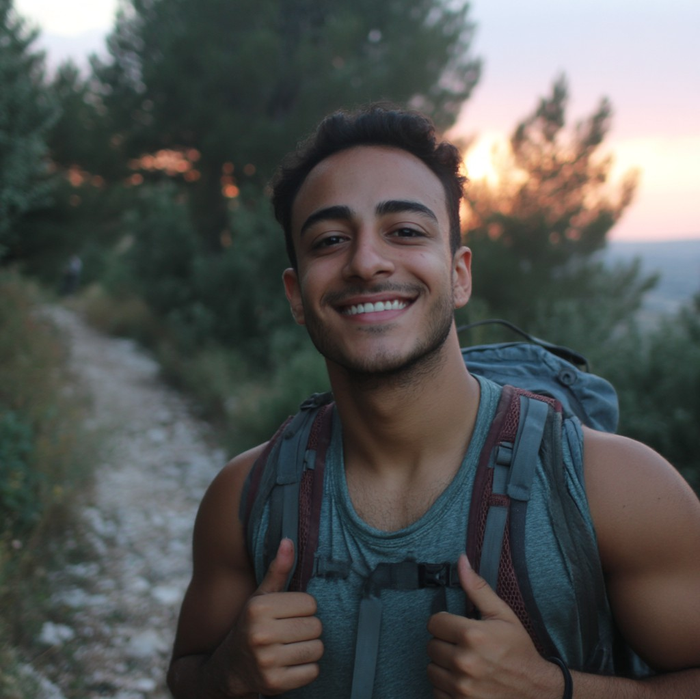

Yusuf (@yusuf_vs_theworld)

1. Influencer Handle
   * Brand/Alias: yusuf vs the world
   * Main Handles:
     + Instagram: @yusufVStheworld
     + TikTok: @yusuf.vs.the_world
     + YouTube: Yusuf Vs The World
2. Platform(s) & Follower Counts
   * Instagram: 18,000 followers
   * TikTok: 21,000 followers
   * YouTube: 10,000 subscribers
3. Content Type & Niche
   * Primary Content: Holistic wellness, running, mindfulness, yoga, alternative therapies
   * Sub-genres/Series:
     + “Run & Reflect” (combining running sessions with guided mindfulness or meditation)
     + “Mindful Movement” (blend of yoga and low-impact recovery routines)
     + “Healing Journeys” (personal stories and audience features about alternative therapy in sports recovery)
     + “Crystal Healing Tips” (posts about using crystals for sports injury recovery and energy balance)
4. Posting Frequency & Activity
   * Typical Posts:
     + Instagram: 2 posts/week (holistic running tips, recovery routines, wellness stories)
     + TikTok: 2–3 videos/week (guided breathing, “healing hacks,” yoga demos)
     + YouTube: 1–2 videos/month (mindfulness for athletes, “alternative recovery” vlogs)
   * Activity: Consistent, with more posts during running or wellness event seasons
5. Audience Demographics
   * Age Distribution:

o 18–24: 45%

o 25–34: 47%

o 35+: 8%

* + Gender Split: 60% women, 36% men, 4% non-binary/other
  + Top Locations: London, Birmingham, Cairo, Manchester, Dubai
  + Other Insights:
    - Audience is drawn to spiritual/alternative wellness, running, and mind-body connection
    - Followers often seek advice on stress reduction, gentle fitness, and holistic healing
    - Culturally diverse, spiritually curious, with notable engagement from British-Arab and North African communities

1. Engagement Metrics
   * Instagram:
     + Avg. likes/post: 590
     + Avg. comments/post: 21
     + Engagement rate: 3.4%
     + Stories: 1,900 avg. views
   * TikTok:
     + Avg. views/video: 1,600
     + Avg. comments/video: 15
     + Engagement rate: 2.8%
   * YouTube:
     + Avg. views/video: 340
     + Avg. comments/video: 7
     + Engagement rate: 1.1%
2. Brand Partnerships & Sponsored Content
   * Brands Worked With:
     + Mindful Path, ChillAloe, VIREO, CrystalWave, CalmSpace, BalanceLife
   * Types of Sponsored Content:
     + Wellness routine integrations, yoga mat and eco gear reviews, “healing journeys” testimonial series, mindfulness event sponsorships
3. Brand Persona & Image
   * Traits: Gentle, spiritual, open-minded, encouraging, holistic
   * Voice/Style: Calm, soothing, occasionally mystical; uses gentle music, spiritual motifs, and guided meditation scripts
4. Potential Audience Overlaps
   * Overlap With:
     + Maya (mindfulness/yoga), Ari (recovery), Priya (wellness/plant-based), Layla (mental health/wellness)
5. Potential Controversies
   * Significant: Promotes crystal healing for sports injury recovery, sometimes making claims about “accelerated healing”; this has attracted skeptical comments and pushback from healthcare professionals
   * Reputation: Responds to criticism by encouraging open dialogue; never deletes comments, but doesn’t walk back claims. Brands with strict evidence standards may hesitate
6. Pricing & Collaboration Terms
   * Instagram Post: £110
   * Instagram Story (3 slides): £40
   * TikTok Video: £80
   * YouTube Video: £75
   * Multi Cross-platform (one post per platform): £250
   * Discounts: 15% for misc. bundles, 10%/month for ongoing
   * Negotiation: Very open, particularly for wellness and spiritual brands
7. Strengths & Unique Selling Points
   * Uniquely spiritual, holistic approach to running and recovery
   * Highly trusted among followers seeking alternative wellness
   * Strong engagement on mindfulness and yoga content
   * Connects cultural and spiritual themes to modern fitness

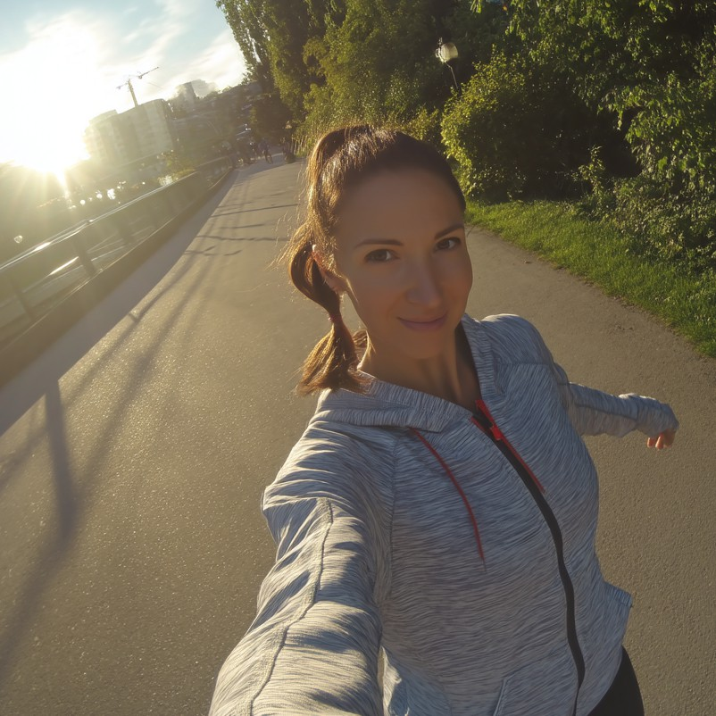

Carys (@carystravelsize)

1. Influencer Handle
   * Brand/Alias: carystravels
   * Main Handles:
     + Instagram: @carystravelsize
     + YouTube: Cary - Travel Size
     + TikTok: @carystravelsize
2. Platform(s) & Follower Counts
   * Instagram: 8,000 followers
   * YouTube: 4,000 subscribers
   * TikTok: 9,000 followers
3. Content Type & Niche
   * Primary Content: Eco-travel, running tourism, green getaways, sustainable gear reviews
   * Sub-genres/Series:
     + “Run the World” (destination running vlogs, highlighting scenic trails and city runs)
     + Reviews of green hotels, hostels, and eco-retreats
     + “Gear for Go” (lightweight, sustainable kit reviews for travelers)
     + “Runner’s Travel Guide” (tips, itineraries, and budget breakdowns)
4. Posting Frequency & Activity
   * Typical Posts:
     + Instagram: 1–2 posts/week (travel highlights, gear flatlays, scenic shots)
     + YouTube: 1 video/2–3 weeks (travelogues, eco-stay reviews, running tours)
     + TikTok: 1–2 videos/week (quick “run the city” reels, eco gear demos)
   * Activity: Regular with occasional content bursts during travel
5. Audience Demographics
   * Age Distribution:

o 18–24: 42%

o 25–34: 50%

o 35+: 8%

* + Gender Split: 69% women, 28% men, 3% non-binary/other
  + Top Locations: Cardiff, London, Bristol, Bangor, Barcelona
  + Other Insights:
    - Viewers are students, young professionals, eco-tourists, and aspiring travel runners
    - High engagement on affordable “staycation” tips, green packing guides, and travel Q&A

1. Engagement Metrics
   * Instagram:
     + Avg. likes/post: 210
     + Avg. comments/post: 11
     + Engagement rate: 2.8%
     + Stories: 540 avg. views
   * YouTube:
     + Avg. views/video: 120
     + Avg. comments/video: 3
     + Engagement rate: 1.2%
   * TikTok:
     + Avg. views/video: 380
     + Avg. comments/video: 7
     + Engagement rate: 2.1%
2. Brand Partnerships & Sponsored Content
   * Brands Worked With:
     + GreenStride, EcoStay UK, Travel Lite
   * Types of Sponsored Content:
     + Gear review integrations, eco-hotel/stay features, destination collabs, “runner’s travel guide” sponsored posts
3. Brand Persona & Image
   * Traits: Adventurous, eco-conscious, friendly, practical, inspiring
   * Voice/Style: Warm, informative, wanderlust-driven; mixes practical advice with dreamy visuals
4. Potential Audience Overlaps
   * Overlap With:
     + Leah Campbell (outdoor/wild running), Kian Murphy (city/adventure running), Maya (eco-wellness/travel)
5. Potential Controversies
   * Mild: Sometimes features destinations or experiences (luxury stays, pricey eco-resorts, distant locations) that are not accessible to all student/young viewers
   * Reputation: Tries to balance aspirational and practical content, but brands should clarify

target segment before partnering

1. Pricing & Collaboration Terms
   * Instagram Post: £80
   * Instagram Story (3 slides): £25
   * YouTube Video: £70
   * TikTok Video: £50
   * Multi Cross-platform (one post per platform): £180
   * Discounts: 15% for misc. bundles, 10%/month for long-term deals
   * Negotiation: Very open, especially for sustainable and travel brands with accessible offers
2. Strengths & Unique Selling Points
   * Unique focus on eco-travel and “running tourism”
   * Provides detailed guides for green packing and affordable running trips
   * Inspires “run the world” wanderlust with authentic and beautiful visuals
   * Connects travel, wellness, and sustainability communities

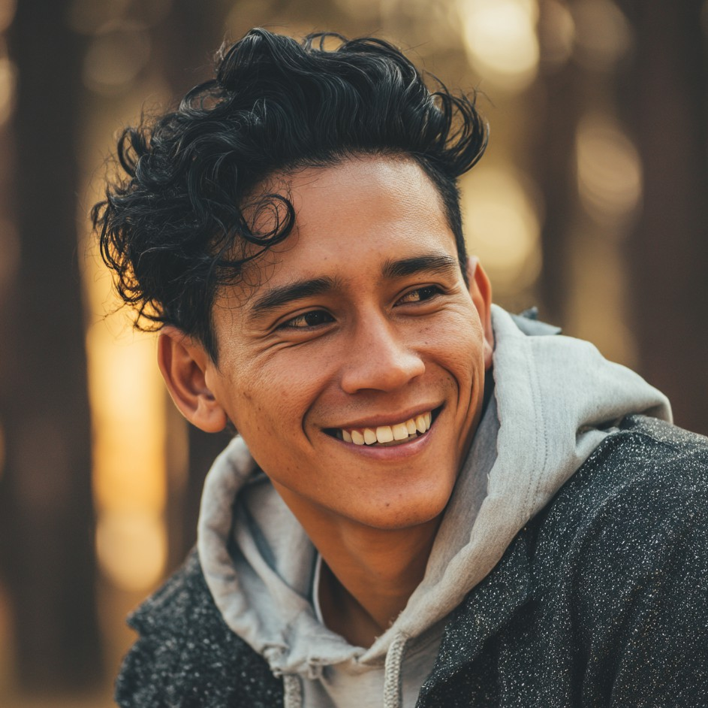

Rajiv (@runwithrajiv)

1. Influencer Handle
   * Brand/Alias: runwithrajiv
   * Main Handles:
     + Instagram: @runwithrajiv
     + TikTok: @runwithrajiv
     + YouTube: Run with Rajiv
2. Platform(s) & Follower Counts
   * Instagram: 12,000 followers
   * TikTok: 6,000 followers
   * YouTube: 2,000 subscribers
3. Content Type & Niche
   * Primary Content: Tech reviews for runners, running gadgets, product comparisons, running routines
   * Sub-genres/Series:
     + “Tech Meets Run” (in-depth reviews of fitness trackers, headphones, hydration gadgets)
     + “Accessory Showdown” (side-by-side comparisons and honest verdicts)
     + “Gadget on the Go” (quick reviews and unboxings during runs)
     + “Runner’s Routine” (occasional training updates, gear picks)
4. Posting Frequency & Activity
   * Typical Posts:
     + Instagram: 2 posts/week (gear reviews, unboxing photos, training highlights)
     + TikTok: 1–2 videos/week (gadget tests, accessory demos, POV runs)
     + YouTube: 1–2 videos/month (detailed reviews, tech deep-dives)
   * Activity: Regular, with more content during major tech launches or race events
5. Audience Demographics
   * Age Distribution:

o 18–24: 51%

o 25–34: 41%

o 35+: 8%

* + Gender Split: 62% men, 36% women, 2% non-binary/other
  + Top Locations: London, Leicester, Birmingham, Cardiff, Mumbai
  + Other Insights:
    - Audience of “techy” runners, students, and new hobbyists
    - Viewers enjoy honest pros/cons, budget picks, and quirky product experiments
    - Follower base includes both gadget geeks and casual runners

1. Engagement Metrics
   * Instagram:
     + Avg. likes/post: 380
     + Avg. comments/post: 10
     + Engagement rate: 3.2%
     + Stories: 900 avg. views
   * TikTok:
     + Avg. views/video: 600
     + Avg. comments/video: 8
     + Engagement rate: 2.0%
   * YouTube:
     + Avg. views/video: 70
     + Avg. comments/video: 2
     + Engagement rate: 0.9%
2. Brand Partnerships & Sponsored Content
   * Brands Worked With:
     + RunTech, VIREO, Garmin, ChillAloe, PaceLab
   * Types of Sponsored Content:
     + Tech review integrations, accessory “showdown” collabs, training vlogs with gear highlights, event demos
3. Brand Persona & Image
   * Traits: Analytical, nerdy, practical, straightforward, approachable
   * Voice/Style: Geeky, slightly quirky, explains with visuals and simple analogies; always honest about product limitations
4. Potential Audience Overlaps
   * Overlap With:
     + Dev (in-depth reviews), Luca (performance gadgets), Priya (science-based product analysis)
5. Potential Controversies
   * Mild: Tech reviews sometimes dominate his feed, causing running content to take a back seat. Can dilute focus for strictly running-focused campaigns
   * Reputation: Followers value honesty and detail, but brands should clarify campaign

content mix

1. Pricing & Collaboration Terms
   * Instagram Post: £90
   * Instagram Story (3 slides): £30
   * TikTok Video: £50
   * YouTube Video: £65
   * Multi Cross-platform (one post per platform): £160
   * Discounts: 15% for misc. bundles, 10%/month for ongoing
   * Negotiation: Open, especially for tech and gear brands targeting runners
2. Strengths & Unique Selling Points
   * Deep, nerdy tech focus with honest comparisons
   * Approachable and clear communicaton, good for new/budget runners
   * Quirky, relatable style appeals to younger, geekier audience
   * Regularly covers affordable and accessible gear



Tina (@tinawellcity)

1. Influencer Handle
   * Brand/Alias: tinawellcity
   * Main Handles:
     + Instagram: @tinawellcity
     + TikTok: @tinawellcity
     + YouTube: Tina Well City
2. Platform(s) & Follower Counts
   * Instagram: 3,800 followers
   * TikTok: 4,100 followers
   * YouTube: 1,200 subscribers
3. Content Type & Niche
   * Primary Content: Everyday fitness, quick city jogs, low-impact routines, practical meal- prep, student wellness
   * Sub-genres/Series:
     + “City Jog Logs” (short city runs with motivational tips and route highlights)
     + “Easy Wellness Hacks” (practical tips for staying healthy with limited time/space)
     + “Meal-Prep for Movers” (easy, budget-friendly meal ideas for active students)
     + “Wellness on the Go” (gentle routines for busy schedules, self-care Q&As)
4. Posting Frequency & Activity
   * Typical Posts:
     + Instagram: 1–2 posts/week (jog selfies, wellness tips, quick recipes)
     + TikTok: 2 videos/week (routine demos, mini meal-preps, pep talks)
     + YouTube: 1–2 videos/month (routine walkthroughs, city living advice)
   * Activity: Steady, with rare short breaks around exam seasons or personal events
5. Audience Demographics
   * Age Distribution:

o 18–24: 60%

o 25–34: 34%

o 35+: 6%

* + Gender Split: 75% women, 22% men, 3% non-binary/other
  + Top Locations: London, Manchester, Birmingham, Glasgow, Hong Kong
  + Other Insights:
    - Large student and young professional audience
    - Attracts viewers interested in practical wellness and fitness for beginners
    - Fans appreciate her gentle encouragement, simplicity, and “it’s okay to do less” approach

1. Engagement Metrics
   * Instagram:
     + Avg. likes/post: 140
     + Avg. comments/post: 8
     + Engagement rate: 3.1%
     + Stories: 340 avg. views
   * TikTok:
     + Avg. views/video: 330
     + Avg. comments/video: 7
     + Engagement rate: 2.3%
   * YouTube:
     + Avg. views/video: 48
     + Avg. comments/video: 1
     + Engagement rate: 0.8%
2. Brand Partnerships & Sponsored Content
   * Brands Worked With:
     + ChillAloe, VIREO, Sable Water, CityFit UK, BudgetFit
   * Types of Sponsored Content:
     + “Wellness hack” integrations, student meal-prep features, city run gear reviews, gentle routine demos
3. Brand Persona & Image
   * Traits: Supportive, practical, calm (with flashes of wit), “realistic” wellness advocate
   * Voice/Style: Gentle, upbeat, speaks from personal experience; approachable, with a focus on sustainability and easy wins
4. Potential Audience Overlaps
   * Overlap With:
     + Layla (student wellness), Zhang (practical eco fitness), Bethan Evans (budget/accessible wellness), Ari (gentle routines)
5. Potential Controversies
   * Notable: Public argument with a doctor influencer over NHS wait times—her criticisms were factually justified but delivered in unexpectedly sharp, sarcastic language. This clash with her usual persona surprised followers, leading to some negative press and lingering doubts about her “genuineness.” She posted a public apology and returned to positive content, but trust has only partially recovered.
   * Reputation: Generally viewed as genuine, but now seen by some as “two-faced” or

inconsistent; careful about tone in current posts

1. Pricing & Collaboration Terms
   * Instagram Post: £45
   * Instagram Story (3 slides): £16
   * TikTok Video: £28
   * YouTube Video: £20
   * Multi Cross-platform (one post per platform): £75
   * Discounts: 12% for misc. bundles, 8%/month for long-term
   * Negotiation: Very open, especially for brands targeting students, women, and beginner-friendly wellness
2. Strengths & Unique Selling Points
   * Exceptionally accessible, practical fitness and wellness for city students
   * Known for honest, supportive, non-intimidating approach
   * Good at bite-sized, budget-friendly content
   * Fills gap for “it’s okay to do less” wellness, especially during stressful seasons



Natasha (@callmenatasha)

1. Influencer Handle
   * Full Name: Natasha
   * Brand/Alias: callmenatasha
   * Main Handles:
     + Instagram: @callmenatasha
     + TikTok: @callmenatasha
     + YouTube: Call Me Nat
2. Platform(s) & Follower Counts
   * Instagram: 2,900 followers
   * TikTok: 3,300 followers
   * YouTube: 900 subscribers
3. Content Type & Niche
   * Primary Content: Style and eco-athleisure hauls, sustainable fashion, wellness trends for young women
   * Sub-genres/Series:
     + “Haul or Hype?” (reviewing new activewear and eco gear drops)
     + “Wardrobe Reset” (seasonal capsule wardrobes, closet swaps)
     + “Fitspiration Finds” (trending styles, gym selfies, motivational fashion tips)
4. Posting Frequency & Activity
   * Typical Posts:
     + Instagram: 2 posts/week (style hauls, lookbook reels, brand tags)
     + TikTok: 2 videos/week (quick outfit flips, unboxing, “style in motion”)
     + YouTube: 1 video/month (longer hauls, wardrobe tours)
   * Activity: Generally regular, with more posts around sales and new gear launches
5. Audience Demographics
   * Age Distribution:

o 18–24: 63%

o 25–34: 30%

o 35+: 7%

* + Gender Split: 87% women, 10% men, 3% non-binary/other
  + Top Locations: London, Liverpool, Manchester, Bogotá, Birmingham
  + Other Insights:
    - Audience of young women, who are students and eco-fashion enthusiasts
    - High engagement on new gear drops and mix-and-match style reels
    - Follows for outfit inspiration, budget eco-style tips, and wellness “glow up” content

1. Engagement Metrics
   * Instagram:
     + Avg. likes/post: 1720
     + Avg. comments/post: 17
     + Engagement rate: 4.8%
     + Stories: 1390 avg. views
   * TikTok:
     + Avg. views/video: 1780
     + Avg. comments/video: 20
     + Engagement rate: 4.0%
   * YouTube:
     + Avg. views/video: 2120
     + Avg. comments/video: 28
     + Engagement rate: 3.7%
2. Brand Partnerships & Sponsored Content
   * Brands Worked With:
     + Sable Water, ChillAloe, UrbanFit, EcoEdit
   * Types of Sponsored Content:
     + Eco-style hauls, lookbook integrations, seasonal capsule swaps, “haul or hype” product reviews
3. Brand Persona & Image
   * Traits: Stylish, upbeat, trend-driven, “eco-glam,” relatable
   * Voice/Style: Bubbly, confident, visually polished; lots of “style inspo” energy and wellness positivity
4. Potential Audience Overlaps
   * Overlap With:
     + Rory Zhang (sustainable fashion), Layla (wellness trends), Priya (eco-living), Bethan Evans (budget hauls)
5. Potential Controversies
   * Significant: Repeatedly reposts and recycles sponsored content, sometimes giving the impression of ongoing partnerships without disclosure.
   * Reputation: Audience is mostly unaware, but several brands have noticed and are wary;

Natasha has not directly addressed it.

1. Pricing & Collaboration Terms
   * Instagram Post: £35
   * Instagram Story (3 slides): £20
   * TikTok Video: £24
   * YouTube Video: £15
   * Multi Cross-platform (one post per platform): £60
   * Discounts: 10% for misc. bundles, 7%/month for ongoing
   * Negotiation: Very open, keen for any eco-fashion and wellness tie-ins
2. Strengths & Unique Selling Points
   * Strong eye for mix-and-match eco fashion, style-forward content
   * Accessible and relatable for young women, especially students
   * Good production value, lots of “outfit inspo” and practical styling
   * Fills niche for affordable “eco-glam” hauls

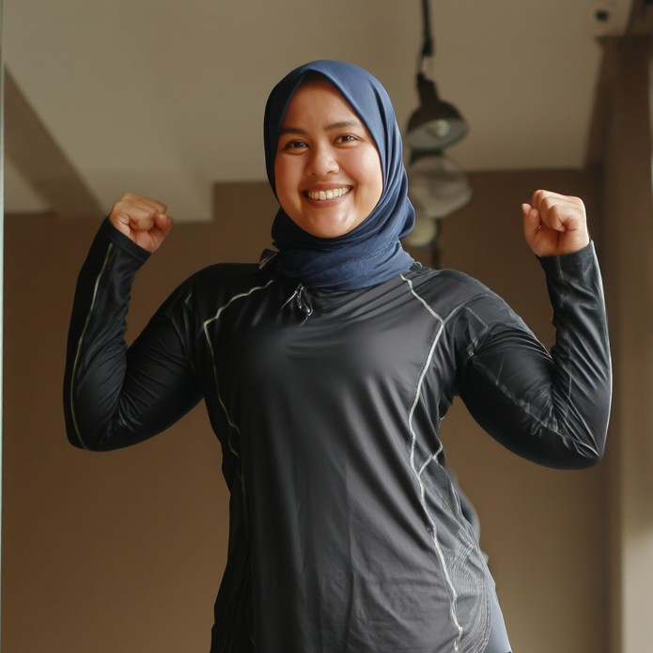

Ari (@arirunrecover)

1. Influencer Handle
   * Brand/Alias: arirunrecover
   * Main Handles:
     + Instagram: @arirunrecover
     + TikTok: @arirunrecover
     + YouTube: Ari Run Recover
2. Platform(s) & Follower Counts
   * Instagram: 5,500 followers
   * TikTok: 4,200 followers
   * YouTube: 1,500 subscribers
3. Content Type & Niche
   * Primary Content: Eco-friendly running routines, recovery methods, first-timer running tips
   * Sub-genres/Series:
     + “Run Recovery 101” (stretching, foam rolling, gentle routines for beginners)
     + “Nutrition for New Runners” (simple, accessible food tips for recovery and stamina)
     + “Day in the Life” (behind-the-scenes vlogs on balancing fitness, school, and downtime)
4. Posting Frequency & Activity
   * Typical Posts:
     + Instagram: 1–2 posts/week (stretching routines, meal preps, eco swaps)
     + TikTok: 1–2 videos/week (quick tips, recovery demos, everyday fitness moments)
     + YouTube: 1–2 videos/month (deeper dives, run recovery walk-throughs, day-in- life)
   * Activity: Steady, with occasional boosts during race seasons or local events
5. Audience Demographics
   * Age Distribution:

o 18–24: 63%

o 25–34: 30%

o 35+: 7%

* + Gender Split: 77% women, 19% men, 4% non-binary/other
  + Top Locations: Jakarta, London, Birmingham, Surabaya, Singapore
  + Other Insights:
    - Followers are mostly first-time runners, students, and beginner fitness enthusiasts
    - High engagement on “real life” posts, meal-prep reels, and stretching demos
    - Audience values approachable, non-intimidating advice and authentic content

1. Engagement Metrics
   * Instagram:
     + Avg. likes/post: 490
     + Avg. comments/post: 8
     + Engagement rate: 3.2%
     + Stories: 420 avg. views
   * TikTok:
     + Avg. views/video: 620
     + Avg. comments/video: 6
     + Engagement rate: 2.4%
   * YouTube:
     + Avg. views/video: 260
     + Avg. comments/video: 2
     + Engagement rate: 3.1%
2. Brand Partnerships & Sponsored Content
   * Brands Worked With:
     + VIREO, ChillAloe, Wellness Collective
   * Types of Sponsored Content:
     + Sponsored run recovery tutorials, gear swaps, “eco routine” integrations, meal- prep collabs
3. Brand Persona & Image
   * Traits: Warm, relatable, gentle, accessible, supportive
   * Voice/Style: Down-to-earth, practical, quietly motivating; makes running and recovery feel achievable for all
4. Potential Audience Overlaps
   * Overlap With:
     + Layla (wellness, relatable advice), Tina (practical student wellness), Yusuf El-Amin (mindful routines), Cassie (inclusive, first-timer fitness)
5. Potential Controversies
   * Mild: Branded/sponsored posts often underperform compared to “day-in-the-life” or organic content. Sponsored collaborations may feel less authentic to her audience
   * Reputation: Maintains trust by being selective with sponsors and always sharing honest

feedback

1. Pricing & Collaboration Terms
   * Instagram Post: £30
   * Instagram Story (3 slides): £20
   * TikTok Video: £30
   * YouTube Video: £50
   * Multi Cross-platform (one post per platform): £80
   * Discounts: 12% for misc. bundles, 7%/month for long-term deals
   * Negotiation: Very open, especially for eco, wellness, and beginner-focused brands
2. Strengths & Unique Selling Points
   * Exceptionally relatable, approachable for first-time runners
   * Practical, non-intimidating advice on eco routines and recovery
   * High trust for honest reviews and gentle, real-life vlogs
   * Small but dedicated and diverse audience, with strong Southeast Asian reach

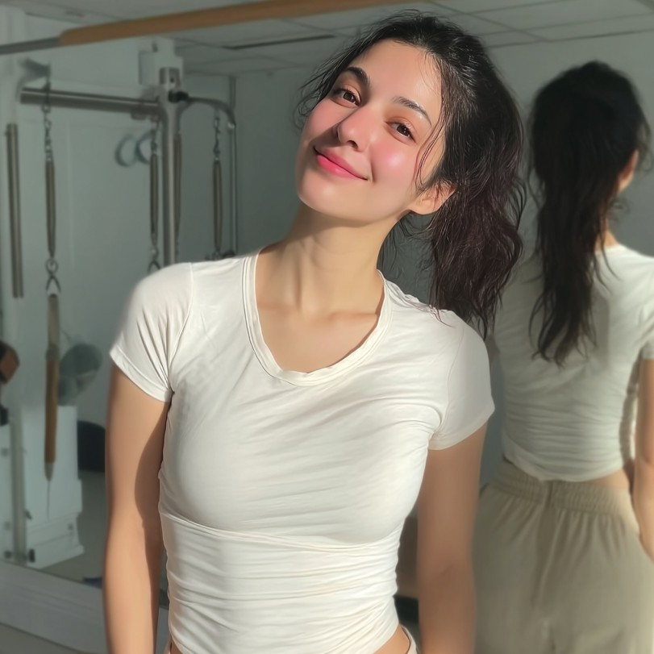

Hannah (@hannahtherunner)

1. Influencer Handle
   * Brand/Alias: hannahtherunner
   * Main Handles:
     + TikTok: @hannahtherunner
     + Instagram: @hannahtherunner
     + YouTube: Hannah the Runner
2. Platform(s) & Follower Counts
   * TikTok: 3,100 followers
   * Instagram: 2,200 followers
   * YouTube: 700 subscribers



1. Content Type & Niche
   * Primary Content: Bite-sized running tips, “easy swaps” for sustainability, beginner- friendly wellness
   * Sub-genres/Series:
     + “Green Run Tips” (simple running advice, often with a sustainability angle)
     + “Eco-Easy Swaps” (quick reels about making sustainable choices in daily life)
     + “Starter Routines” (basic running and warm-up guides for first-timers)
     + “Motivation Minis” (pep talks and easy wins for new runners)
2. Posting Frequency & Activity
   * Typical Posts:
     + TikTok: 2 videos/week (running tips, easy swaps, mini-challenges)
     + Instagram: 1–2 posts/week (quick tips, infographics, wellness check-ins)
     + YouTube: 1 video/month (basic how-tos, beginner guides)
   * Activity: Regular and reliable, especially during back-to-school and spring/summer seasons
3. Audience Demographics
   * Age Distribution:

o 18–24: 74%

o 25–34: 23%

o 35+: 3%

* + Gender Split: 83% women, 14% men, 3% non-binary/other
  + Top Locations: London, Manchester, Liverpool, Bristol, Birmingham
  + Other Insights:
    - Follower base is mostly students and young adults just starting fitness journeys
    - Viewers appreciate approachable, non-intimidating advice and “anyone can start” message
    - Limited engagement from advanced runners or seasoned fitness buffs

1. Engagement Metrics
   * TikTok:
     + Avg. views/video: 160
     + Avg. comments/video: 5
     + Engagement rate: 2.2%
   * Instagram:
     + Avg. likes/post: 70
     + Avg. comments/post: 5
     + Engagement rate: 3.2%
     + Stories: 180 avg. views
   * YouTube:
     + Avg. views/video: 58
     + Avg. comments/video: 4
     + Engagement rate: 0.7%
2. Brand Partnerships & Sponsored Content
   * Brands Worked With:
     + EcoFit, BudgetFit, RunSimple
   * Types of Sponsored Content:
     + Product placements in “easy swap” tips, beginner-friendly challenge integrations, IG reels with green product demos
3. Brand Persona & Image
   * Traits: Friendly, encouraging, practical, relatable, beginner-focused
   * Voice/Style: Simple, upbeat, keeps advice direct and unintimidating; loves making fitness and eco-living feel accessible
4. Potential Audience Overlaps
   * Overlap With:
     + Tina (student-friendly wellness), Ari (gentle, practical advice), Layla (wellness on a budget), Bethan Evans (local/beginner running)
5. Potential Controversies
   * Mild: Tips are sometimes so simplified that more advanced or ambitious followers disengage; rarely posts more challenging or technical advice
   * Reputation: Known for “keep it simple” mantra; some requests for more advanced or

varied content, but her brand is firmly “accessible first”

1. Pricing & Collaboration Terms
   * TikTok Video: £20
   * Instagram Post: £18
   * Instagram Story (3 slides): £10
   * YouTube Video: £17
   * Multi Cross-platform (one post per platform): £24
   * Discounts: 10% for misc. bundles, 5%/month for ongoing
   * Negotiation: Very open; values brands focused on accessibility, student deals, and green living
2. Strengths & Unique Selling Points
   * Ultra-accessible, beginner-friendly advice; low intimidation factor
   * Focus on simple eco habits for city students
   * Cheerful, supportive voice that encourages fitness “from zero”
   * Consistent content for start-of-journey runners

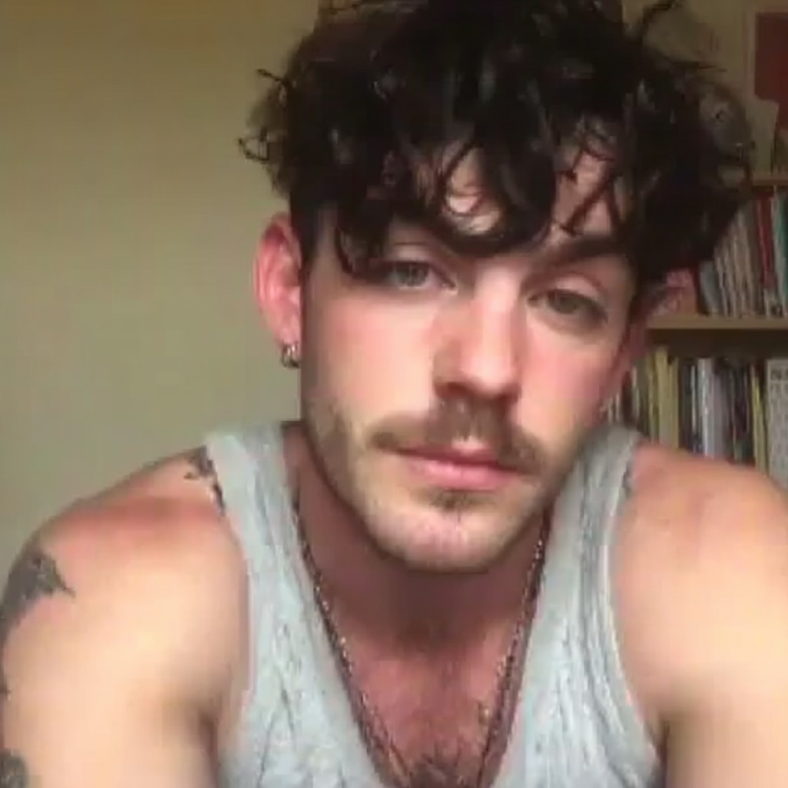

Sam (@sammorisson)

1. Influencer Handle
   * Brand/Alias: sammorisson
   * Main Handles:
     + Instagram: @sammorisson
     + TikTok: @sammorisson
     + YouTube: Sam Moirsson Moves
2. Platform(s) & Follower Counts
   * Instagram: 9,200 followers
   * TikTok: 13,000 followers
   * YouTube: 3,600 subscribers
3. Content Type & Niche
   * Primary Content: “Run with me” vlogs, honest gear reviews, fitness community building
   * Sub-genres/Series:
     + “Run With Sam” (POV vlogs and guided runs)
     + “Real Talk Reviews” (gear reviews—pros, cons, and candid impressions)
     + “Challenge Check-Ins” (monthly goals, setbacks, and updates on training progress)
     + “Community Shoutouts” (featuring followers, local runners, or gear tips from fans)
4. Posting Frequency & Activity
   * Typical Posts:
     + Instagram: 2 posts/week (run recaps, shoutouts, gear picks)
     + TikTok: 2–3 videos/week (vlogs, quick reviews, motivational check-ins)
     + YouTube: 2 videos/month (longer “run with me” vlogs, gear roundups)
   * Activity: Very consistent; content sometimes spikes before/after race events
5. Audience Demographics
   * Age Distribution:

o 18–24: 50%

o 25–34: 40%

o 35+: 10%

* + Gender Split: 56% men, 40% women, 4% non-binary/other
  + Top Locations: London, Liverpool, Sheffield, Manchester, Birmingham
  + Other Insights:
    - Community vibe is central—followers interact regularly, tag each other, and share run stories
    - Sam’s “honest review” approach and self-deprecating humor boost trust
    - Strong engagement with regional UK runners and fitness newcomers

1. Engagement Metrics
   * Instagram:
     + Avg. likes/post: 250
     + Avg. comments/post: 12
     + Engagement rate: 2.8%
     + Stories: 600 avg. views
   * TikTok:
     + Avg. views/video: 500
     + Avg. comments/video: 10
     + Engagement rate: 2.3%
   * YouTube:
     + Avg. views/video: 160
     + Avg. comments/video: 6
     + Engagement rate: 1.7%
2. Brand Partnerships & Sponsored Content
   * Brands Worked With:
     + VIREO, PaceLab, ChillAloe, GreenStride, BudgetFit
   * Types of Sponsored Content:
     + “Run with me” sponsored vlogs, honest gear review integrations, Instagram Q&A or “real talk” product posts
3. Brand Persona & Image
   * Traits: Honest, supportive, transparent, self-deprecating, community-oriented
   * Voice/Style: Candid, occasionally cheeky, sometimes uses regional slang; combines encouragement with humor and realism
4. Potential Audience Overlaps
   * Overlap With:
     + Cassie (community fitness), Layla (wellness), Luca (casual run vlogs), Tina (accessible student wellness)
5. Potential Controversies
   * Mild: Frequent use of regional slang and UK in-jokes can limit accessibility and appeal outside his core audience
   * Reputation: Community loves the authentic touch, but brands seeking

national/international reach should request more “universal” content when needed

1. Pricing & Collaboration Terms
   * Instagram Post: £32
   * Instagram Story (3 slides): £12
   * TikTok Video: £20
   * YouTube Video: £25
   * Multi Cross-platform (one post per platform): £60
   * Discounts: 10% for misc. bundles, 8%/month for ongoing
   * Negotiation: Very open, especially for brands focused on authenticity, beginner-friendly fitness, and community campaigns
2. Strengths & Unique Selling Points
   * Exceptionally high trust—followers love the honesty and “real life” approach
   * Strong community interaction; followers feel seen and heard
   * Candid, self-deprecating humor makes sponsored content more relatable
   * Fills the niche for regional, everyday running content

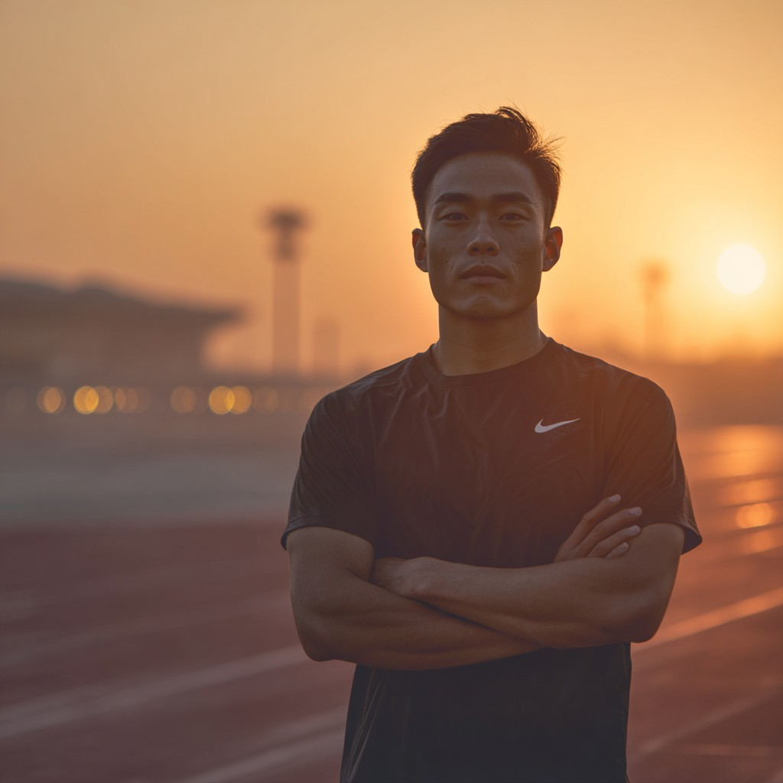

Kenji (@kenjicityrun)

1. Influencer Handle
   * Brand/Alias: kenjicityrun
   * Main Handles:
     + Instagram: @kenjicityrun
     + TikTok: @kenjicityrun
     + YouTube: Kenji City Run
2. Platform(s) & Follower Counts
   * Instagram: 7,800 followers
   * TikTok: 12,000 followers
   * YouTube: 2,200 subscribers
3. Content Type & Niche
   * Primary Content: Minimalist city running, tech reviews for runners, eco gear for urban life
   * Sub-genres/Series:
     + “City Run Aesthetics” (stylized city jogs, architecture shots, minimalist workout vlogs)
     + “Tech for Tiny Spaces” (best fitness gadgets for small apartments and urban living)
     + “Smart Run Gear” (in-depth reviews of watches, headphones, and smart accessories)
     + “Route of the Week” (highlighting London’s coolest and most underrated running routes)
4. Posting Frequency & Activity
   * Typical Posts:
     + Instagram: 1–2 posts/week (aesthetic city shots, gear flatlays, quick tips)
     + TikTok: 2 videos/week (urban run vlogs, tech reviews, POV gear demos)
     + YouTube: 1 video/month (detailed gadget reviews, urban route guides)
   * Activity: Highly variable—peaks during tech launches, new gear drops, and spring/summer; quieter in winter or between campaigns
5. Audience Demographics
   * Age Distribution:

o 18–24: 59%

o 25–34: 35%

o 35+: 6%

* + Gender Split: 61% men, 36% women, 3% non-binary/other
  + Top Locations: London, Tokyo, Manchester, Birmingham, Edinburgh
  + Other Insights:
    - Audience skews young, urban, tech-savvy, and design-conscious
    - Strong appeal for students and new professionals in small city flats
    - High engagement from followers interested in minimalist aesthetics and eco gear

1. Engagement Metrics
   * Instagram:
     + Avg. likes/post: 230
     + Avg. comments/post: 7
     + Engagement rate: 3.0%
     + Stories: 390 avg. views
   * TikTok:
     + Avg. views/video: 410
     + Avg. comments/video: 8
     + Engagement rate: 2.2%
   * YouTube:
     + Avg. views/video: 60
     + Avg. comments/video: 1
     + Engagement rate: 0.7%
2. Brand Partnerships & Sponsored Content
   * Brands Worked With:
     + RunTech, VIREO, EcoFit, Minimal Gear, ChillAloe
   * Types of Sponsored Content:
     + Tech gear integrations, “best gadgets for city runners,” urban gear styling reels, route highlights with product placements
3. Brand Persona & Image
   * Traits: Minimalist, techy, calm, visual, detail-oriented
   * Voice/Style: Clean, concise, visually driven; prefers sleek visuals, pastel/monochrome palettes, and direct-to-camera gear demos
4. Potential Audience Overlaps
   * Overlap With:
     + Rajiv Sharma (tech reviews), Zhang (minimalist eco style), Luca (urban running), Tina (city wellness)
5. Potential Controversies
   * Mild: Highly variable engagement—posts spike during major launches or tech drops, but dip in off-seasons or when posting less frequently
   * Reputation: No major controversies; transparent about posting schedule and takes

breaks for “content quality over quantity”

1. Pricing & Collaboration Terms
   * Instagram Post: £50
   * Instagram Story (3 slides): £60
   * TikTok Video: £75
   * YouTube Video: £100
   * Multi Cross-platform (one post per platform): £250
   * Discounts: 12% for misc. bundles, 7%/month for long-term
   * Negotiation: Very open, especially for brands with sleek, modern, or eco/tech angles
2. Strengths & Unique Selling Points
   * Strong city/minimalist visual style, appealing to young urban runners
   * Relatable tech and gear advice for small apartment/urban living
   * Consistent focus on eco gear and smart solutions
   * High spikes in engagement around launches and new releases

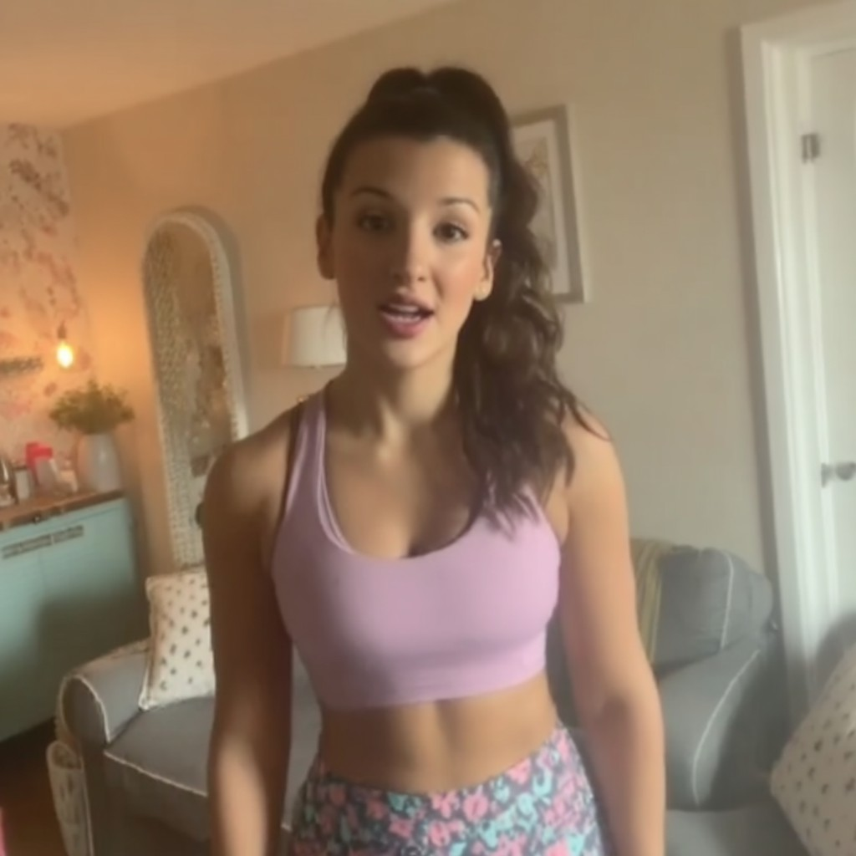

Charlotte (@runwithcharlotte)

1. Influencer Handle
   * Brand/Alias: runwithcharlotte
   * Main Handles:
     + Instagram: @runwithcharlotte
     + TikTok: @runwithcharlotte
     + YouTube: Run with Charlotte
2. Platform(s) & Follower Counts
   * Instagram: 15,000 followers
   * TikTok: 6,300 followers
   * YouTube: 2,000 subscribers
3. Content Type & Niche
   * Primary Content: Gentle running, mental health, injury recovery, re-entering fitness
   * Sub-genres/Series:
     + “Gentle Run Diaries” (slow run logs, mindfulness moments, gentle progress updates)
     + “Back to Fitness” (recovery journeys, injury support, motivation for starting over)
     + “Mental Health Mondays” (open chats, supportive vlogs, Q&A)
     + “Culture Conversations” (discusses running trends, opinions on training culture)
4. Posting Frequency & Activity
   * Typical Posts:
     + Instagram: 2 posts/week (gentle run recaps, wellness check-ins, supportive messages)
     + TikTok: 1–2 videos/week (short vlogs, mental health tips, gentle workouts)
     + YouTube: 1 video/month (deep-dive discussions, Q&A, interview collabs)
   * Activity: Consistent, especially around “restart” and mental health awareness seasons
5. Audience Demographics
   * Age Distribution:

o 18–24: 56%

o 25–34: 39%

o 35+: 5%

* + Gender Split: 90% women, 8% men, 2% non-binary/other
  + Top Locations: London, Bristol, Manchester, Edinburgh, Leeds
  + Other Insights:
    - Follower base is primarily young women recovering from burnout/injury or restarting fitness
    - High engagement on supportive, open, and honest posts
    - Followers seek community, encouragement, and gentle advice—not “hardcore” motivation

1. Engagement Metrics
   * Instagram:
     + Avg. likes/post: 380
     + Avg. comments/post: 18
     + Engagement rate: 2.6%
     + Stories: 620 avg. views
   * TikTok:
     + Avg. views/video: 210
     + Avg. comments/video: 5
     + Engagement rate: 2.1%
   * YouTube:
     + Avg. views/video: 60
     + Avg. comments/video: 2
     + Engagement rate: 1.0%
2. Brand Partnerships & Sponsored Content
   * Brands Worked With:
     + ChillAloe, Wellness Collective, Mindful Path
   * Types of Sponsored Content:
     + Gentle run routines, “recovery journey” content, mental health campaign integrations, supportive challenge posts
3. Brand Persona & Image
   * Traits: Supportive, honest, thoughtful, sometimes opinionated, resilient
   * Voice/Style: Calm, open, gentle but direct; not afraid to share strong views on running culture and recovery
4. Potential Audience Overlaps
   * Overlap With:
     + Layla (wellness, candid advice), Hannah (gentle/beginner fitness), Ari (recovery- first content), Tina (mental health/wellness)
5. Potential Controversies
   * Mild: Has strong, sometimes polarizing opinions on running culture—occasionally debates followers or pushes back in comment sections, which can make brands nervous about potential for online disputes
   * Reputation: Highly respected for honesty; followers appreciate debate, but brands

sometimes request content moderation for sensitive topics

1. Pricing & Collaboration Terms
   * Instagram Post: £32
   * Instagram Story (3 slides): £11
   * TikTok Video: £15
   * YouTube Video: £19
   * Multi Cross-platform (one post per platform): £60
   * Discounts: 12% for misc. bundles, 8%/month for long-term
   * Negotiation: Very open, especially for wellness, recovery, and mental health brands
2. Strengths & Unique Selling Points
   * Powerful support for women restarting fitness after injury or burnout
   * Honest, no-nonsense voice with gentle encouragement
   * Fills a needed gap for “gentle” running and mental health-first content
   * Active, engaged community; frequent two-way conversation

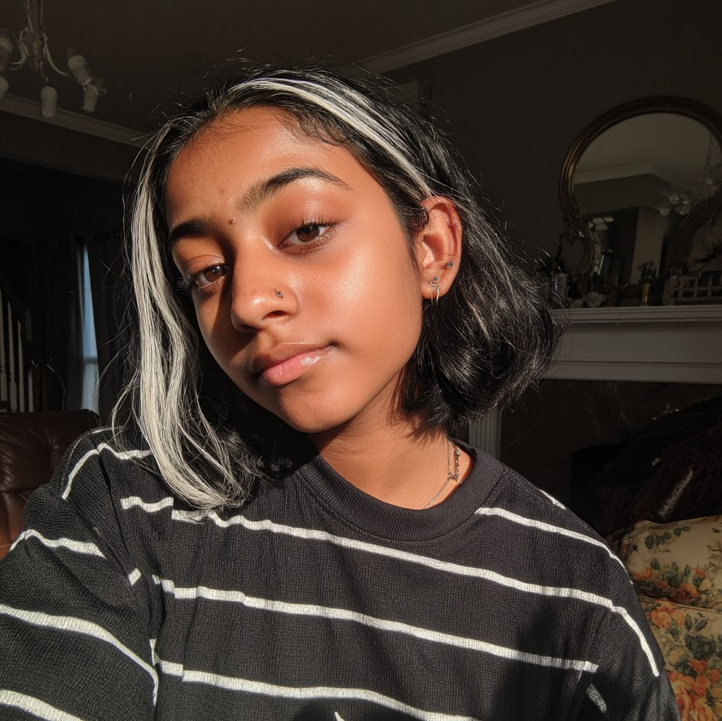

Anika Sethi (@anika4all)

1. Influencer Handle
   * Brand/Alias: anikainclusive
   * Main Handles:
     + Instagram: @anika4all
     + TikTok: @anika4all
     + YouTube: Anika Inclusive
2. Platform(s) & Follower Counts
   * Instagram: 9,500 followers
   * TikTok: 13,000 followers
   * YouTube: 4,100 subscribers
3. Content Type & Niche
   * Primary Content: Inclusive fitness, LGBTQ+ running, accessible training, sustainability
   * Sub-genres/Series:
     + “Run with Pride” (spotlighting LGBTQ+ runners, inclusive gear, allyship tips)
     + “Ask Anika” (Q&A on training, accessibility, and non-binary experiences in sport)
     + “Day in the Life” (vlogs mixing running, activism, and everyday wellness)
4. Posting Frequency & Activity
   * Typical Posts:
     + Instagram: 2 posts/week (inclusive training highlights, Q&A, gear picks)
     + TikTok: 2–3 videos/week (short vlogs, product demos, “run with me” stories)
     + YouTube: 2 videos/month (deeper dives, inclusive running advice, social commentary)
   * Activity: Consistent, with extra content during Pride, LGBTQ+ History Month, and major campaigns
5. Audience Demographics
   * Age Distribution:

o 18–24: 53%

o 25–34: 40%

o 35+: 7%

* + Gender Split: 62% women, 16% men, 22% non-binary/other
  + Top Locations: London, Manchester, Brighton, Birmingham, Glasgow
  + Other Insights:
    - Strong LGBTQ+ and non-binary following
    - Highly engaged in discussions of accessibility, inclusivity, and sustainability
    - Audience values community, visibility, and practical advice for “everybody”

1. Engagement Metrics
   * Instagram:
     + Avg. likes/post: 310
     + Avg. comments/post: 15
     + Engagement rate: 3.4%
     + Stories: 650 avg. views
   * TikTok:
     + Avg. views/video: 600
     + Avg. comments/video: 11
     + Engagement rate: 2.7%
   * YouTube:
     + Avg. views/video: 430
     + Avg. comments/video: 15
     + Engagement rate: 4.3%
2. Brand Partnerships & Sponsored Content
   * Brands Worked With:
     + VIREO, Sable Water, GreenStride, Mindful Path
   * Types of Sponsored Content:
     + Inclusive gear reviews, Pride campaign integrations, “accessible fitness” challenges, Q&A sponsorships
3. Brand Persona & Image
   * Traits: Inclusive, activist, supportive, candid, community-focused
   * Voice/Style: Warm, thoughtful, openly discusses both running and broader social topics; mixes informative and personal content
4. Potential Audience Overlaps
   * Overlap With:
     + Cassie (inclusive fitness), Priya (accessible/eco content), Tina (wellness for all), Layla (student/wellness tips)
5. Potential Controversies
   * Notable: Occasionally discusses social topics beyond running (e.g., trans rights, inclusive sports policies, activism) which can polarize or alienate more conservative audiences and some brands
   * Reputation: Audience is highly loyal, but some mainstream brands hesitate with

outspoken advocacy content

1. Pricing & Collaboration Terms
   * Instagram Post: £38
   * Instagram Story (3 slides): £15
   * TikTok Video: £25
   * YouTube Video: £26
   * Multi Cross-platform (one post per platform): £100
   * Discounts: 12% for misc. bundles, 8%/month for ongoing
   * Negotiation: Very open, especially for inclusive, accessible, and sustainability-focused brands
2. Strengths & Unique Selling Points
   * Uniquely inclusive, non-binary and LGBTQ+ perspective on running and wellness
   * Highly supportive, welcoming, and practical advice
   * Regular Q&A builds community trust and ongoing engagement
   * Advocates for accessible, sustainable fitness for all